# Quantum Technologies Conceptual Framework Programme

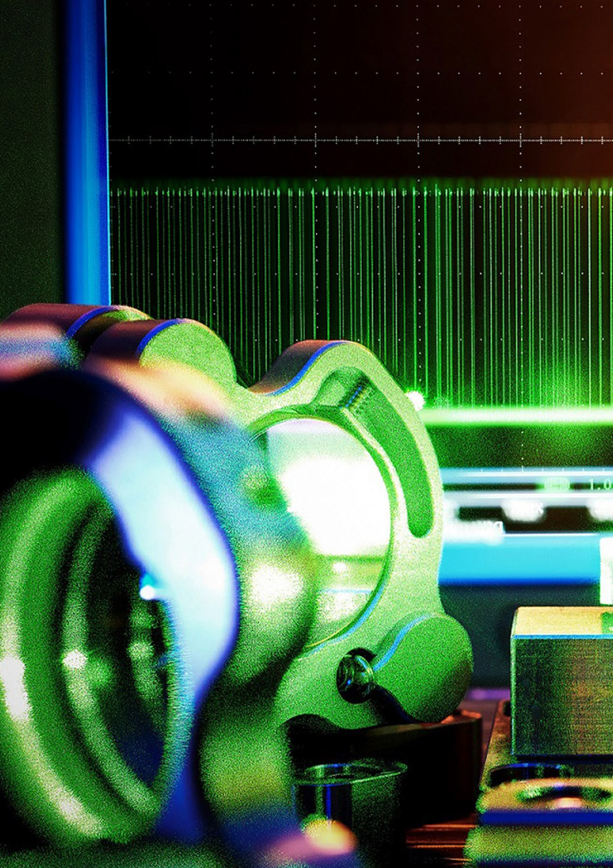

**of the Federal Government**

**1**

*Contents*

1. Exploiting the potential of quantum technologies for Germany *3*
2. Huge challenges, extraordinary potential *8*

Quantum computing and quantum simulation 9

Post-quantum cryptography and quantum communication 9

Quantum sensor technology and quantum metrology 10

Enabling technologies 10

An international comparison of the state of technologies 10

Technology strands 13

Quantum computing and quantum simulation 13

Quantum communication 14

Quantum sensor technology and quantum metrology 15

1. Top-level technology for creative power and technological sovereignty *16*
   1. Make quantum technologies usable for the economy, society and state institutions 18

Economic innovative strength 19

Societal challenges 20

Security and sovereignty 22

* 1. Drive forward targeted technology development with a view to future application 23

Pushing technological boundaries 23

Setting standards 23

Technology lighthouse: quantum computing 25

* 1. Create excellent framework conditions for a strong ecosystem 27

Create interfaces: strengthen ecosystems 27

Strengthen start-up culture and innovative companies 27

Awaken interest, attract skilled workers 28

Keeping an eye on impact: identifying opportunities and considering effects 29

1. Acting together – securing sovereignity *31*

Joint action by the Federal Government 31

Interdisciplinary interfaces 32

Network with national actors 32

Build strong international partnerships and secure technological sovereignty 32

1. Milestones and resource planning *34*

Quantum computing 35

Quantum sensor technology 35

Quantum communication and post-quantum cryptography 35

Characterisation and standardisation 36

Resource planning 36

1. Annex *37*

Ministerial research programmes, strategies and measures with reference

to the conceptual framework programme 37

Overview of activities of subordinate authorities, agencies and institutionally funded bodies 39

1. Glossary *53*

Imprint *54*

**New technologies have a huge impact on our everyday lives: they form the basis for a wide range of possibilities within the digital world, the foundation for the effective generation of energy, new forms of mobility and innovative medical technology. For a future-proof and technologically sovereign Germany, it is crucial to identify upcoming technologies and their potential as early as possible, to create excellent framework conditions for their future design and use, and to actively shape technology leaps. Quantum technologies are a future technology that have the po-tential to disrupt and offer particularly promising prospects for use. Although they are still at a comparatively early development stage, innovative uses within the economy and society are already emerging, which also address the challenges noted above.**

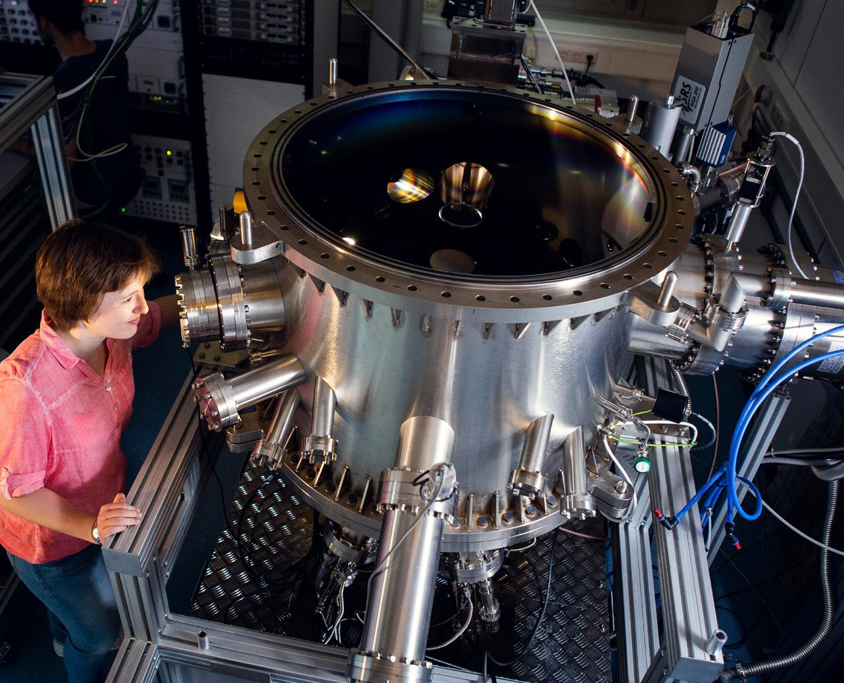

1. Exploiting the potential of quantum technologies for Germany

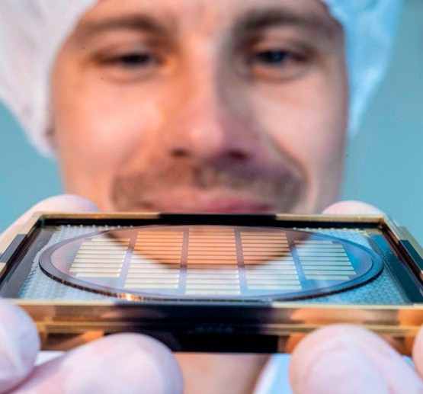The time horizon as well as the expected impact of the various key technologies involved in quantum technologies are different:1 with regard to enabling technologies and core components for quantum technologies, there is already a corporate landscape of start-ups and large companies within Germany. The first products related to quantum sensor technology, quantum materials and quantum communication have also reached market maturity. In contrast, quantum computing is only expected to be widely used in the medium to long term, although it does offer enormous development potential.2, 3 Like any

other new technology, quantum technologies not only provide opportunities but also challenges, and it is important to keep track of them. For example, quan-tum computers will be powerful enough in the long term to threaten the security of traditional digital communications with the cryptography that is used today. The migration to cryptographic procedures that are resistant to quantum computing is therefore inevitable and is something that already needs to be under consideration.4

Germany is in a good position in terms of quantum technologies. Because of its proven research landscape, Germany ranks fourth behind the USA, China and Great Britain in terms of relevant publications when looking at things on an international scale and it has the most publications of any European country.5 Ger-many is also in the top four for patent families, behind China, the USA and Japan. The focus of German pat-ent families is on quantum measurement technology and quantum electronics.6 It is important to make use of this strong foundation.

Against this backdrop the Federal Government’s goal is to move Germany and Europe into a leading inter-national position in quantum technologies through targeted, long-term support and then to further con-solidate this position. In terms of quantum comput-ing, the aim is to catch up with the technology leaders. This ensures technological sovereignty, increases val-ue creation potential and opens up great opportunities for the use of technology in the economy and society.

This is why the application-oriented development of quantum technologies in Germany must be advanced in a targeted manner. This encompasses:

* securing and expanding Germany’s innovative strength and technological sovereignty in quantum technologies;
* working towards the development and production of marketable products;
* using quantum technologies to help overcome so-cietal challenges linked to climate research, energy, health, mobility and security;
* training and attracting skilled workers and devel-oping Germany as an appealing place to work for quantum technologies;
* introducing people to quantum technologies, com-municating opportunities and, in doing so, demon-strating the implications thereof, and
* ensuring a coordinated, joint approach by the Fed-eral Government.
  1. Kagermann, H./Süssenguth, F./Körner, J./Liepold, A.: [The Innovation Potential of Second-generation Quantum Technologies](https://www.acatech.de/publikation/innovationspotenziale-der-quantentechnologien/) (acatech IMPULS), Munich 2020
  2. McKinsey & Company: [Quantum Technology Monitor](https://www.mckinsey.de/%7E/media/mckinsey/business%20functions/mckinsey%20digital/our%20insights/quantum%20computing%20funding%20remains%20strong%20but%20talent%20gap%20raises%20concern/quantum-technology-monitor.pdf) (accessed on 22.11.2022)
  3. Boston Consulting Group: [What Happens When ‘If’ Turns to ‘When’ in Quantum Computing?](https://www.bcg.com/publications/2021/building-quantum-advantage) (2022)
  4. Federal Office for Information Security (BSI): [Kryptografie quantensicher gestalten](https://www.bsi.bund.de/SharedDocs/Downloads/DE/BSI/Publikationen/Broschueren/Kryptografie-quantensicher-gestalten.html) (2021)
  5. McKinsey & Company: [Quantum Technology Monitor](https://www.mckinsey.de/%7E/media/mckinsey/business%20functions/mckinsey%20digital/our%20insights/quantum%20computing%20funding%20remains%20strong%20but%20talent%20gap%20raises%20concern/quantum-technology-monitor.pdf) (accessed on 22.11.2022)
  6. Krek, M.: [Quantum Technologies Patents, Publications & Investments](https://www.researchgate.net/publication/350453567_Quantum_Technologies_Patents_Publications_Investissements_Landscape), Ecole Polytechnique Paris (2020)

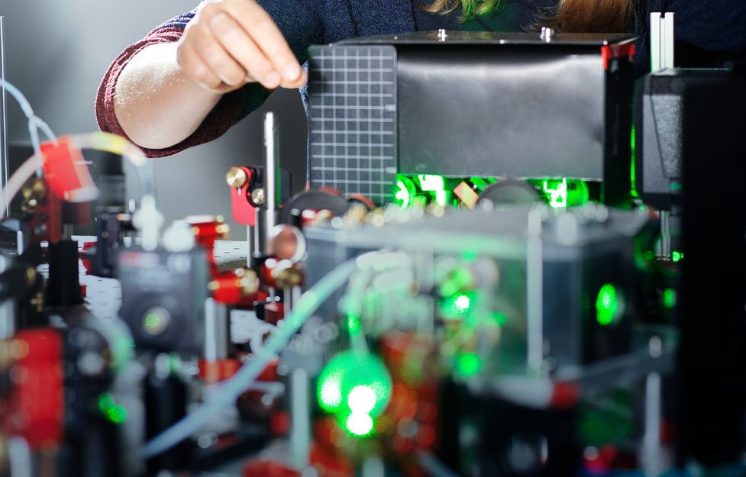

Central to this is the establishment of an efficient ecosystem in which all relevant actors along the value chain work together in a tightly interconnected manner. The dovetailing of fundamental and applied research and the early involvement of end users will ensure that the technology develops in line with

actual requirements. The integration of partners from the business community is an important building block in this respect. Furthermore, active positioning with regard to the development of standards and the development of required quantum metrology are also of great importance. The aim is to in this way tap into the expected enormous market potential in the area of application.7 The consequences for cyber security, and therefore for the digitalisation of Germany, that arise from the development of quantum technologies must also be considered at an early stage.

With this conceptual framework programme the Federal Government is providing itself with a political framework until 2026 for measures to be taken in the field of quantum technologies. At the same time the concept forms part of a long-term strategy. This is be-cause in order to fully utilise the potential of quantum technologies, additional stages beyond the conceptual

framework programme will have to be created (see also Vision 2036 in Section 3).

The federal ministries are responsible for imple-menting the individual components of the Federal Government’s interministerial conceptual frame-work programme. They will check the success of the respective measures against measurable targets and milestones. These indicators are continuously moni-tored, reviewed and successively updated at the level of measures and conceptual framework programme concepts, thereby allowing dynamic developments in quantum technologies to be taken into account.

In order to address the key challenges, the Federal Government is pursuing three central areas of focus. These primarily rely on public co-financing with the aim of triggering, strengthening and accelerating private initiatives and investments in Germany. De-pending on the area of application, this takes different forms, for example, through contracts, direct project funding or shares in associated companies (especially venture capital).

* 1. Kagermann, H./Süssenguth, F./Körner, J./Liepold, A.: [The Innovation Potential of Second-generation Quantum Technologies](https://www.acatech.de/publikation/innovationspotenziale-der-quantentechnologien/) (acatech IMPULS), Munich 2020

## Several people sit in a laboratory environment. They wear full-body protective suits, masks and goggles. Make quantum technologies useful for the economy, society and governmental institutions

We will encourage market development and the use of technologies for socially relevant issues. By 2026 in Germany we want to:

* + - Significantly expand the usability and application of quantum technologies in all key technologies as a whole.

**→** All ministries

* + - Open up quantum computing in Germany and Eu-rope for practical applications in business, adminis-tration and society. The long-term goal of technolog-ical sovereignty in quantum computing in Germany and the EU is looked at across all components and levels that build upon each other (full stack).

**→** BMBF, BMWK

* + - Strengthen skills in the design and development of quantum algorithms across different research areas, e. g., in the field of optimisation or quantum machine learning.

**→** BMBF, BMWK

* + - Develop quantum communication components that can be used in practical scenarios and bring them to market, establish a well-networked quan-tum communication industry in Germany and ensure the transfer of expertise from science to industry.

**→** BMBF, BMF, BMI, BMWK

* + - Drive forward the migration to quantum-safe cryp-tography (post-quantum cryptography, PQC) in Germany, especially in relevant areas (e. g., critical infrastructures).8

**→** BMI, BMVg, BMBF

* + - Create marketable products in the quantum sensor technology sector using lighthouse applications.

**→** BMBF, BMWK

* Develop optical clocks for the next Galileo gener-ation and, together with European partners, drive forward the development of the next generation of satellite-based gravity field quantum sensors (up to Technology Readiness Level [TRL] 5).

**→** BMWK

* Investigate the impact and benefits of quantum technologies in public administration, especially with regard to communication security, and imple-ment appropriate measures.

**→** BMI, BMF

8 This is also a goal of the [Cyber Security Strategy for Germany 2021](https://www.bmi.bund.de/EN/topics/it-internet-policy/cyber-security-strategy/cyber-security-strategy-node.html)

## Drive forward targeted technology developments with a view to future applications

Due to fact that many technology strands are in the early stage of development, far-sighted and long-term measures are required to drive research and develop-ment forward in a targeted manner with a clear view on how they can be used. By 2026 in Germany we want to:

* secure and expand Germany’s strong position in enabling technologies through targeted measures.

**→** BMBF, BMWK

* develop next-generation chips for quantum tech-nologies, e. g., for quantum computers or use in quantum sensors.

**→** BMBF, BMWK

* develop quantum computing hardware based on different approaches in an application-oriented manner. In doing so we are striving for a universal quantum computer on a par with international developments and at least 100 individually control-lable qubits, scalable to 500 qubits in the medi-

um term. In addition, high-performance special hardware should be developed for suitable fields of application.

**→** BMWK, BMBF

* strengthen skills in the design and development of quantum algorithms across different research areas, e. g., in the field of optimisation or quantum machine learning.

**→** BMBF, BMWK

* develop and bring to market key components for sensors, navigation and communication that are suitable for space travel and ready for market.

**→** BMWK

* establish a quality infrastructure and reliable quan-tum metrology to create independent characterisa-tion, qualification and standardisation for specific components for quantum technologies.

**→** BMWK, BMBF

## Create excellent framework conditions for a strong ecosystem

In international competition it is crucial that Germany and Europe can offer attractive and stimulating frame-work conditions. By 2026 in Germany we want to:

* ensure the close networking of all actors and activi-ties in science, the economy and politics.

**→** All ministries

* strengthen the education and training of pro-fessionals in the field of quantum technologies through a coherent programme that includes junior academics, technical staff and professional devel-opment.

**→** BMBF, BMWK

* create a positive start-up climate to support spin-offs from academia.

**→** BMBF, BMWK

* work towards close dovetailing with European partners at all levels. This includes cooperation on technological issues as well as the development of common standards, including those relating to re-sponsible use and a common quality infrastructure.

**→** All ministries

The quantum technologies conceptual framework programme contributes to the goals of the Federal Government’s ‘Future Strategy for Research and Innovation’. It contributes to securing the techno-logical sovereignty of Germany and Europe with regard to the technologies of the future. In terms of operational implementation, it is supported by specialised programmes, specific implementation

concepts, and measures put forward by the relevant ministries, depending on the level of technological maturity and focus of application. The annex pro-vides an overview of the status quo.

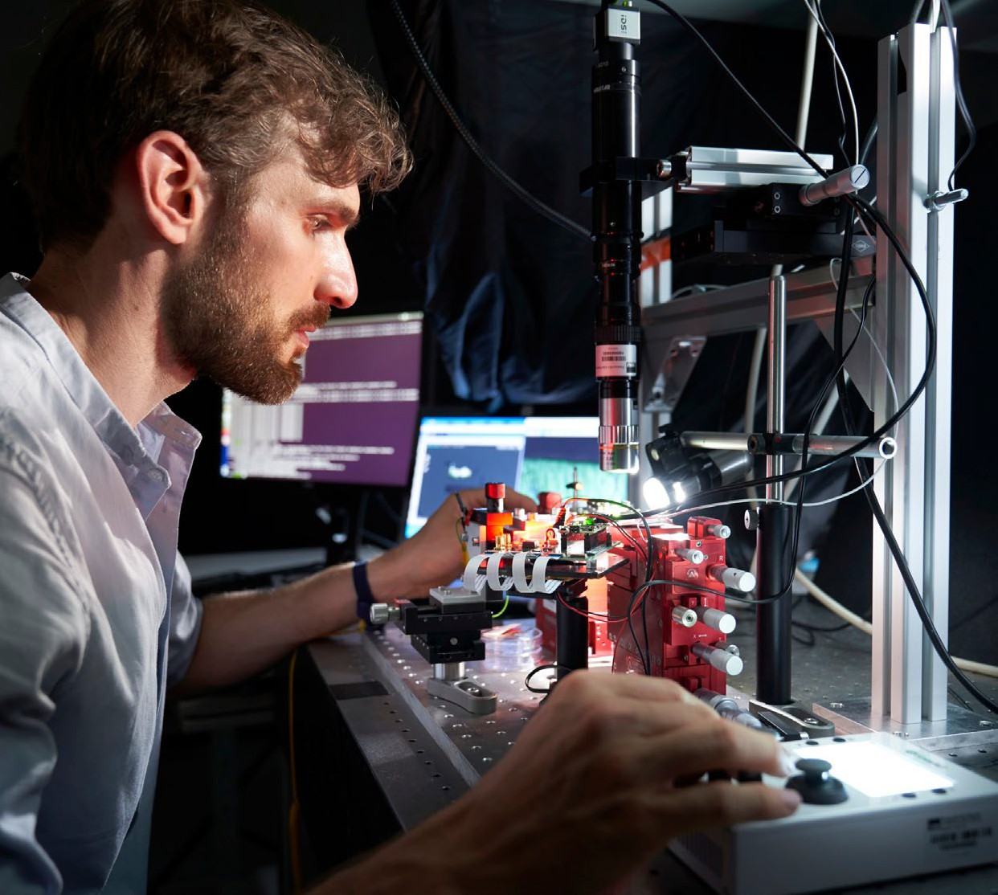

1. Huge challenges, extraordinary potential

**Quantum technologies, i.e., the targeted control of quantum mechanical effects and their technological exploita-tion, promise enormous progress for applications in the economy, society and governmental institutions. Depending on the type of technology (quantum computing and quantum simulation, quantum communication and post-quantum cryptography, quantum sensor technology and quantum metrology, as well as the associated enabling technologies), the application maturity and its possible uses vary.**

## A laser beam that passes through several lenses arranged one after the other. Quantum computing and quantum simulation

The enormous potential is most evident in quantum computing. Traditional computers will reach their limits in the long term, for example, in the simula-tion of chemical reactions and compounds (material sciences, drug design) or the optimisation of complex systems, such as logistical systems. Through new algorithms based on qubits (quantum bits) instead of traditional bits, a quantum computer could deliver clear advantages in this respect. There is also poten-tial, for example, in forecasting weather services and the modelling of climate change and its consequences.

Research has therefore been undertaken into a pleth-ora of technologically different implementations of quantum computers (see also ‘Quantum computing’ info box) and possible use cases. It is not possible, however, to reliably predict which of these approach-es will ultimately be successful or whether different implementations will excel in particular use cases.

However, the technologies have the potential to create completely new possibilities for products and services in a wide range of application areas and industries, thereby having a significant impact on international competition. In the long term studies are working on the basis of an annual market volume of several hun-dred billion euros in quantum computing alone.9 This explains the high level of attention being paid and

the considerable financial commitment to the issue worldwide. Nevertheless, fundamental challenges still need to be overcome in the development of both hard-ware and software, which require long-term research and development activities.

## Post-quantum cryptography and quantum communication

Even though it is not a quantum technology itself, post-quantum cryptography plays an important role in this context. From the IT security point of view, the development of powerful quantum computers poses

a threat: the so-called Shor algorithm, a quantum information technology method, would be able to break the public key cryptography that is in use today. The quantum computing hardware that is required

does not yet exist. However, as soon as this is available, it would pose an incalculable risk since encryption methods such as this are currently used to secure confidential communications and security-relevant data. Even today, encrypted data can be hacked into and recorded so that it can be decrypted later with future quantum computers (‘store now, decrypt later’). This makes it imperative to develop and introduce new, quantum-safe cryptographic procedures (‘post-quantum cryptography’), which should offer a level

of security against quantum computers at least as high as the aforementioned traditional procedures do today. It should be noted that post-quantum cryptog-raphy can be implemented on traditional hardware in the same way as the public key methods currently in use. This distinguishes it significantly from quantum communication methods and allows it to even be used in situations where quantum communication is not possible, for example, due to physical limitations.

Quantum communication offers enormous potential to secure confidential communication in a highly effective manner. In terms of quantum encryption, quantum physical effects such as entanglement or the fact that it is impossible to create perfect identical copies of individual photon are used for key exchange in order to transmit data securely. Unlike common cryptographic methods, the high level of security

1. Boston Consulting Group: [What Happens When ‘If’ Turns to ‘When’ in Quantum Computing?](https://www.bcg.com/publications/2021/building-quantum-advantage) (2022)

involved in quantum cryptography is based on phys-ical laws of nature and not on mathematical assump-tions. A wide variety of quantum communication methods have since been demonstrated in use, both in optical fibres and between satellites, and in terrestrial free-space connections. For broad application rele-vance, however, it is the range and data rate that still pose a challenge. This is why it is essential to develop quantum repeaters, which are required as nodes to extend the communication-transmission paths, as

a key component for quantum communication over long distances.

## Quantum sensor technology and quantum metrology

Within the field of quantum technologies,

quantum-based metrology is probably the field with the highest technological maturity. For example, nitrogen-vacancy centres in diamond are already used in special microscopes. The first quantum gravime-ters are also available on the market and enable the Earth’s gravitational field to be measured for applica-tions in geology or geodesy.

Quantum sensors also offer new applications that complement traditional technologies. By directly referencing the measurement methods to natural constants, which are without uncertainties defined by the recent redefinition of the SI system of units (2019),10 they offer novel possibilities for reliable, ubiq-

uitous and highly accurate sensor technology. Overall, quantum-based metrology is a heterogeneous field with a wide variety of technologies and numerous op-portunities for promising applications, some of which are already ready for the market.

However, quantum metrology is not limited to quantum sensor technology. It generally relates to performing high-resolution and highly sensitive measurements of physical parameters using quantum effects such as quantum entanglement. Quantum metrology therefore promises the development of measurement techniques that enable greater preci-sion than undertaking the same measurements using

traditional methods. For example, electrical quantum metrology can develop conventional metrology into comprehensive quantum metrology. Among other things, programmable ‘quantum voltmeters’ are already available on the market.

## Enabling technologies

The cross-sectional field of enabling technologies is particularly indispensable when it comes to fur-ther developing quantum technologies. It is already demonstrating economic potential: the first mar-kets for special lasers, control electronics and even

cooling technology for quantum systems have already emerged. Highly specialised start-ups and small and medium-sized enterprises (SMEs) in particular can generate their first sales. The future challenge will

be to develop innovative overall systems from this sum of individual components and to open up further possibilities of use.

As a cross-sectional task it is necessary from the outset to consider and develop an independent metrological characterisation and qualification of components11

in order to achieve a stable, trustworthy and reliable value chain in the emerging quantum technology industry. This guarantees quality, comprehensible and firm performance parameters and the comparability of quantum technology components.

## An international comparison of the state of technologies

Drawing comparisons on an international level, the USA currently leads the world, especially in terms of quantum computing. For example, major corpora-tions such as Google and IBM currently represent the state of the art in superconducting quantum comput-ing. The USA also has the highest number of start-ups in quantum technologies (92), the highest amount of venture capital introduced (USD 2.2 billion from 2001 to 2021) and the most academic research groups (64).12 National funding is distributed among a wide range of national agencies and organisations (including NIST,

1. Pfalz, M.: [Das neue Maß der Einheiten.](https://pro-physik.de/nachrichten/das-neue-mass-der-einheiten) From: [prophysik.de](http://prophysik.de/) (20.05.2019)
2. Tzalenchuk, A. et al.: [The expanding role of National Metrology Institutes in the quantum era.](https://www.nature.com/articles/s41567-022-01659-z) In: Nature Physics 18 (2022)
3. McKinsey & Company: [Quantum Technology Monitor](https://www.mckinsey.de/%7E/media/mckinsey/business%20functions/mckinsey%20digital/our%20insights/quantum%20computing%20funding%20remains%20strong%20but%20talent%20gap%20raises%20concern/quantum-technology-monitor.pdf) (accessed on 22.11.2022)

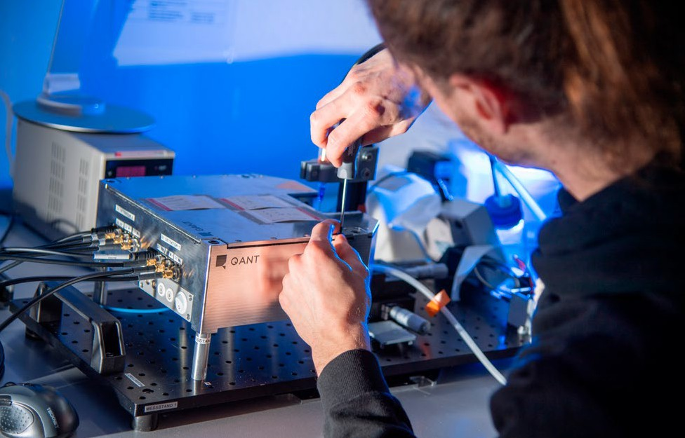

NASA, DARPA) with different thematic and strate-gic focuses. Total government funding in 2022 was approximately USD 0.9 billion.13

When drawing comparisons on an international scale, China has announced the highest level of govern-ment funding by far with a total of USD 15 billion.

Specific structures and strategies are less transparent, but important work has already been published at a scientific and technological level. For example, an intercontinental key exchange was demonstrated in 2018 using quantum cryptographic methods and with the help of the Micius research satellite.14 With regard to quantum computing, there are also an increasing number of developments that indicate a high level of technology.

In the European Union substantial public funding for quantum technologies has now been announced (USD 7.2 billion within the EU compared to USD 1.9 billion in the USA). In Germany, EUR 2 billion of this is available for research and development in quan-tum technologies alone within the framework of the

Federal Government’s Future Package. In contrast, however, there is considerably less venture capital available, especially compared to the USA (USD 0.3 billion compared to USD 2.2 billion). In terms of scientific publications, the European Union is a leader, both when it comes to academic quality and academic breadth. The number of start-ups has also more than tripled since 2015,15, 16 but is far below the numbers in the USA.

For Germany it is important to benefit economical-ly and socially from the development of quantum technologies and to establish sovereign access to this technology of the future. The initial situation is assessed as follows:

1. Gross, N.: [Where Is Quantum Technology Going in the Federal Government?](https://fedtechmagazine.com/article/2022/06/where-quantum-technology-going-federal-government) From: [fedtechmagazine.com](http://fedtechmagazine.com/) (2022)
2. Liao, S.K. et al.: [Satellite-relayed intercontinental quantum network](http://arxiv.org/ftp/arxiv/papers/1801/1801.04418.pdf) In: Physical Review Letters 120 (2018)
3. McKinsey & Company: [Quantum Technology Monitor](https://www.mckinsey.de/%7E/media/mckinsey/business%20functions/mckinsey%20digital/our%20insights/quantum%20computing%20funding%20remains%20strong%20but%20talent%20gap%20raises%20concern/quantum-technology-monitor.pdf) (accessed on 22.11.2022)
4. without Enabling Technologies

|  |  |
| --- | --- |
| **Strengths** | **Weaknesses** |
| * distinct industrial sector with many potential users of the technology * embedding in the European internal market * high level of public investment in the development of quantum technologies * strong fundamental research * good culture of collaboration between science and industry within the framework of cooperative research schemes * ongoing research into almost all relevant technology platforms * established quantum metrology * dual education system and strong university education | * relatively little work in the field of quantum infor-mation theory (lack of research activity) * potential users are still reluctant to use quantum technologies * state of applied computer technology, especially in the field of quantum computing, is behind that of North American companies * when making an international comparison, there is less venture capital available and higher administra-tive hurdles regarding start-ups and their promotion * promotion of talents can be strengthened |

|  |  |
| --- | --- |
| **Opportunities** | **Risks** |
| * Germany’s manufacturing sector could benefit dis-proportionately from the use of quantum technol-ogies * good co-design possibilities for suppliers and users of the technology * new markets for German SMEs as manufacturers of special components * great economic potential through novel applications for the communications sector, sensor technology and computing * technological sovereignty in Europe can be fun-damentally achieved through broad technology coverage | * skills shortage and brain drain, especially of top experts * possible development of critical dependence on non-European hardware and software * threats to Germany’s sovereign and critical infra-structures as well as leading technological compa-nies due to the use of quantum computers by other countries * lack of quality and confidence in the technology in the absence of comparability and independent quali-fication of quantum technology components * standards are set outside of Europe and are not compatible with German products |

This rough analysis demonstrates the great potential for Germany due to its strong base in quantum tech-nologies. It forms the basis for the Federal Govern-

ment’s measures outlined below to bring Germany into a leading international position in quantum technologies and to secure this position.

## Technology strands

**Quantum computing and quantum simulation** While conventional computers work with bits that take the values (0) or (1), a quantum computer uses quantum bits (qubits). These are quantum mechanical systems that come in two states (0) and (1) or in a superposition of them due to the quantum physical effect of superposition. This means that qubits can assume any combination of the two states. In addition, two or more qubits can be ‘entangled’ with each other so that they assume a particular common overall state. A change in one qubit will therefore have immediate effects

on the other entangled qubits, even if they are

spatially separate from each other. This is a funda-mentally different computing principle than that of traditional computers. Due to the enormous scaling with the number of qubits associated with this approach, quantum computers with only a few qubits are already expected to have enormous potential for certain computing operations.

A quantum computer is defined not simply by the number of usable quantum bits (a measure of the size of the problem), but also by the error rates of an operation (it helps to estimate the quality of the result) and the depth of the implementable circuits (i.e., the computational sequences of the quantum operations on the qubits). Circuits with many operations in succession (‘great depth’) enable more complex calculations to be performed. The depth of the circuit depends, among other things, on how long certain physical states can be main-tained ( ‘decoherence time’).

Quantum computers are intrinsically parallel and suitable for huge task sizes, while tradition-al computers only achieve parallelism through many functional units working in parallel and are limited in the size of the problems they can process as a result of their memory. By using the quantum mechanical principles of entanglement and superposition, quantum computers are capa-ble of handling certain tasks that push traditional computers to their limits. A quantum advantage can therefore be achieved with these tasks, for example, in the sense of massively reducing the computing time required, which in many cases makes a solution possible in the first place. Quan-tum computers should in general, and especially in the long-term, be regarded as special hardware

for specific areas and not as a replacement for pre-vious microelectronic computers for broad circles of users.

The development of a practically-relevant quan-tum computer requires the generation and control of numerous qubits. These must not lose their quantum properties for the longest possible time due to interaction with the environment (known as decoherence), although at the same time it must be possible to prepare, entangle and read them out in a controlled manner. To this end a wide variety of physical realisations of architectures for qubits are being developed, from ion traps to electrons in semiconductor structures, superconducting sys-tems to nuclear spins or photons and topological states. All technical implementations have their own set of advantages and disadvantages and it is not possible to predict which of the technological approaches will prevail. Complex further develop-

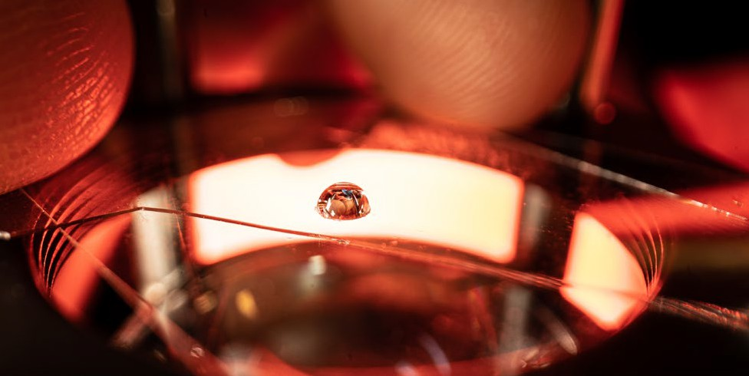

ments of hardware and algorithms are still needed to achieve a universally programmable computer. Since many quantum algorithms react very sensi-tively to disturbances, the ability to correct errors is also a decisive factor here. In addition to robust qubits, special algorithms are also being developed to improve the efficiency of the hardware. In con-trast to a universal quantum computer, quantum simulators represent a controllable system that can be developed to tackle a specific problem.

They are used to mimic another quantum system, thereby simulating specific processes. In this way quantum simulators can model practical proper-ties, for example, in materials research.

### Quantum communication

When it comes to quantum communication, quan-tum states form the basis for the secure trans-mission of information. In this context quantum states are used for key distribution in quantum cryptography. According to the ‘no-cloning theo-rem’, it is impossible to copy unknown quantum states or to measure them without interference.

This is why, with regard to individual quanta and entangled quanta, it is possible to determine whether the information transported with them

has already been read out. It is therefore possible to detect a possible eavesdropping attack on commu-nications that were believed to be secure. Com-pared to previous encryption concepts, safety from

interception of data transmission is not based on complexity assumptions of specific mathematical problems, but on quantum mechanical principles. Since quantum states are very fragile, a number of considerable technical challenges are linked to their transmission. For example, quantum signals must be maintained over long distances and fault conditions must be reduced.

In order to be able to make use of the advantages provided by quantum communication, it must be qualitatively and quantitatively tested in existing IT and communication infrastructures before being gradually integrated. In order to maintain the reliability and availability of communication infrastructures, quantum systems also need to reach a level of maturity that corresponds to that of traditional IT systems. There are possible points of attack, such as the interfaces between quantum and traditional IT systems.

In order to achieve future interoperable applica-tions, as well as a standardised understanding of the security of quantum communication, it is also necessary to standardise basic building blocks such as the protocols used, key management, the integration of quantum repeaters as nodes to ex-tend communication distances, and other network elements.

### Quantum sensor technology and quantum metrology

Quantum states are very sensitive to influences from the surrounding environment. In quantum computing and quantum communication, this means that qubits are very difficult to control for a long enough period of time. But what poses a challenge in one context, can also translate into great advantages elsewhere. Nevertheless, it is precisely this level of sensitivity to external influ-ences that can be used to undertake very precise measurements of underlying physical variables, for example, electric and magnetic fields, gravity or temperature.

A fundamental idea behind quantum sensor tech-nology is to use two states in a quantum system, whereupon the spectroscopic measurable energy difference of them depends on the magnitude of the external influence. Other measurement prin-ciples use wave properties of matter. With quan-tum optics, the entanglement of photons allows extremely precise measurements to be taken and enables imaging in spectral ranges that were pre-viously inaccessible. Quantum-based measuring technology can result in a new level of precision that cannot be achieved using traditional meas-

urement technologies. One challenge is to shield all environmental influences that could result in a false measurement.

Quantum metrology is closely linked to this: it uses quanta to define units of measurement and for other extremely precise research. Quantum mechanics sets the ultimate limit regarding the ac-curacy of any measurement. Quantum metrology therefore uses quantum effects to achieve a higher level of precision than that which is possible with traditional approaches, or to make measurements possible in the first place.

Quantum metrology, also as a result of SI units being redefined, further offers the possibility of drift-free, self-referenced quantum sensors that can be traced to the SI. These can offer significant advantages compared to traditional solutions,

for example, when used as (pressure) sensors in process automation, or quantum electronic com-ponents that directly realise the newly defined SI units and quantities derived therefrom, such as the volt and the ampere.

**Quantum technologies are a future key emerging technology in which Germany is building a strong foundation. The Federal Government’s goal is to take advantage of the available opportunities and to establish Germany and Europe as world leaders in this field. Targeted measures will make quantum technologies usable for society and the econ-omy while securing technological sovereignty. In this context, the Federal Government is guided by a long-term target image where an advanced state of technology and diverse applications will be established by 2036.**

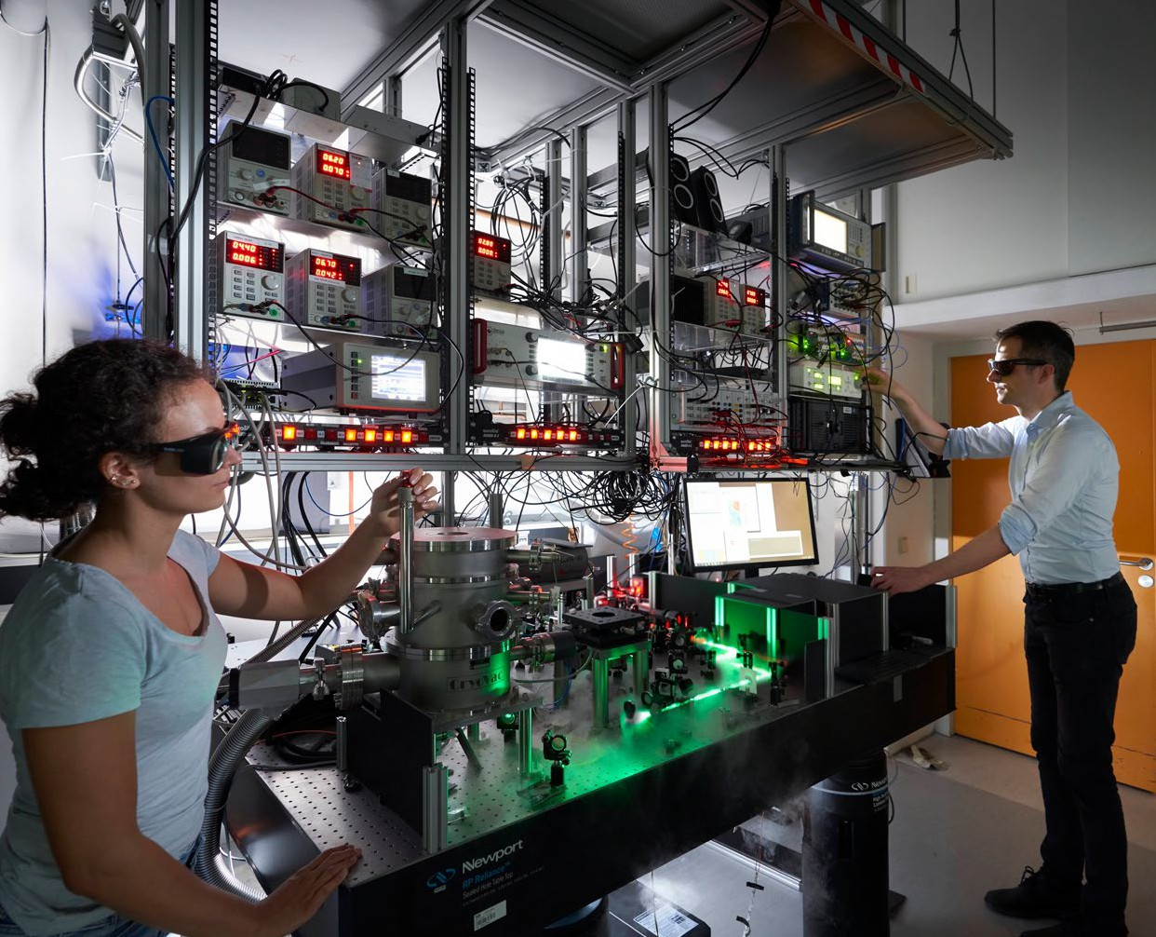

1. Top-level technology for creative power and technological sovereignty
2. QUANTUM TECHNOLOGIES CONCEPTUAL FRAMEWORK PROGRAMME

### Vision 2036

The development of quantum technologies from a fu-ture technology into a central key emerging technol-ogy requires a time horizon that clearly exceeds the time frame of this conceptual framework programme. The Federal Government is therefore relying on a ‘re-search and innovation’ approach – also encouraged by the Expert Commission on Research and Innovation17, 18 to further develop measures and a long-term, sustain-able promotion and development of the technology. In the case of quantum computing, a technology-neutral approach is particularly important until it becomes clearer which realisation of qubits is most advanta-geous for the further development of quantum com-puters. It is also conceivable that different hardware platforms would be particularly suited to different applications.

In the long term quantum technologies should be established as a key emerging technology in a wide range of application fields. By 2036, ten years after the end of this conceptual framework programme, our target image is:

* Quantum technologies are core components in a wide range of economic applications. They make significant contributions to value creation in Ger-many and to dealing with the pressing future issues that face our society, including:
  + Quantum sensors are established in a wide range of economically and socially relevant applica-tions. For example, the construction industry benefits from the use of innovative sensor types in soil exploration, while in medical technology quantum sensors enable new types of diagnos-tics. Furthermore, with regard to information and communication technology, improved signal processing is achieved through the use of high-precision atomic clocks.
  + Complex use cases are solved using universal error-corrected quantum computers manufac-tured in Germany. Quantum computers and special-purpose computers, e. g., quantum sim-ulators or quantum annealers, play a significant

role in several industries, such as the chemical and pharmaceutical industries, the financial sector and the automotive sector.

* Sensitive data in administrative services and emergency services are exchanged via internal administrative networks based on quantum computer-resistant cryptography methods. The internal administrative networks follow secure and defined transitions to other communication partners. Sensitive data within critical infra-structures and the economy are protected by quantum computer-resistant cryptology meth-ods, and in some areas they are additionally secured by quantum communication. Locations of economic, scientific or sovereign relevance are connected via a secure EU-wide quantum communication network.
* German activities in the field of standardisation as well as significantly higher levels of accuracy in time, mass and current standards resulting from quantum metrology form the basis for an international quantum-based standardisation system.
* Quantum technologies are making their contribu-tion to ensure that the German economy remains one of the world’s ten most innovative economies in 2036.19 Together with partners from the European Union, we are technologically independent when

it comes to manufacturing quantum technology products and applications or producing critical el-ements within international value chains (techno-logical sovereignty).20

1. Kagermann, H./Süssenguth, F./Körner, J./Liepold, A.: [The Innovation Potential of Second-generation Quantum Technologies](https://www.acatech.de/publikation/innovationspotenziale-der-quantentechnologien/) (acatech IMPULS), Munich 2020
2. Commission of Experts for Research and Innovation (EFI): [Report on Research, Innovation and Technlogical Performance in Germany 2022](https://www.e-fi.de/en/publications/reports) (2022)
3. In 2021, for example, Germany ranks fourth in the Bloomberg Innovation Index with a score of 86.45, behind South Korea (90.49), Singapore and Swit-zerland. The rest of the top 10 most innovative countries with index values that are above or a little under 84 are quite close to Germany.
4. For example, the latest generations of semiconductors are currently not manufactured in Europe, but in Southeast Asia. However, production is largely dependent on lithography systems from the European Union, to which German suppliers contribute essential components.

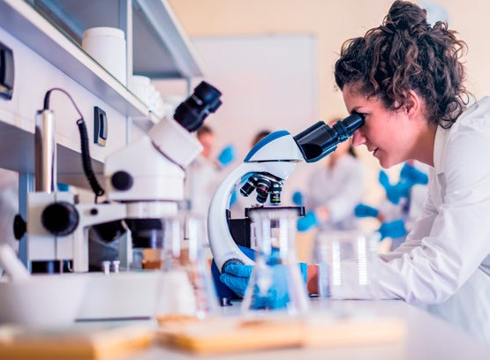The Federal Government’s measures are divided into three action pathways:

## Make quantum technologies usable for the economy, society and state institutions

Quantum technologies will open up a wide range of new possibilities: from the simulation of new active substances to bug-proof communication and novel sensors that detect unexploded bombs or enable navigation without satellite support. Against this background a targeted development of the technology is needed, one that always takes account of possible application scenarios.

This conceptual framework programme of the Federal Government therefore focuses on measures that stim-ulate, strengthen or accelerate private investment in Germany through public co-financing. Depending on the area of application, public support takes different forms.

To this end the Federal Government uses three com-plementary and coordinated funding instruments:

* + In the case of research-related topics that are of considerable federal interest, research and develop-ment in companies, universities and research insti-tutions is supported with subsidies through project funding. These non-repayable grants are primarily aimed at application-oriented project consortia that cover the value chain from technology develop-ment to the end user.
  + Through the targeted awarding of contracts for marketable products, the public sector acts as a central anchor and reference customer for compa-nies that develop and manufacture such hardware in Germany. An example of this is the German Aer-ospace Centre (DLR), which receives core funding and procures innovative quantum computers for its own use through research contracts on the mar-ket by awarding contracts worth around EUR 600 million from the fiscal stimulus package. Positive results from previous tenders show that the novel

approach of DLR’s Quantum Computing Initia-tive has proven to be a good funding route for an entrepreneurial quantum computing ecosystem in Germany.

* The borrowing requirements of young companies that bring new developments to market maturity can also be met through direct public sector partic-ipation. With the new DeepTech & Climate Fonds (DTCF) that forms part of the Future Fund adopted in 2021, the Federal Government is expanding the established financing instruments for start-ups. The fund, which can grow up to EUR 1 billion, makes direct investments in deep-tech companies on pari-passu terms with a longer-term investment perspective, covering quantum technology and other areas in terms of subject area. Alongside the established High-Tech Gründerfonds (HTGF), the DTCF is an example of direct public-sector partici-pation in venture capital.

In order to focus on the ambitious techno-economic goals of the conceptual framework programme for quantum technologies and to do justice to the budg-etary priority of private funding over public funding, the funding measures also successively take into ac-count the increasing degrees of technology maturity as part of their framework conditions.

The aim of the conceptual framework programme is to create a close network of actors who will establish the first products on the market in a timely manner by means of joint research and development. Germa-

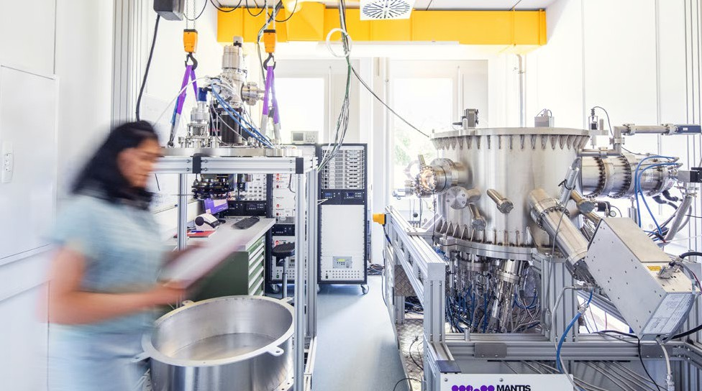

ny can particularly benefit from a large number of po-tential users from many different sectors.21 The rapid and interlocking development of initial pilot applica-tions as well as testbeds22 and standards will allow the technology to be tested in real use scenarios.

The Federal Government can see great potential in the following areas in particular:

### Economic innovative strength

The development of quantum technologies has now progressed to the point that they will enter into a growing number of areas of economic life in the com-ing years. Looking at it in the long term, the successful application of quantum technologies is associated with enormous market potential for German compa-nies, which can use them to offer innovative products and services. In addition to the development and distribution of the technology, a wide range of new opportunities for application are opening up across all sectors, from product development to service offerings.

In the field of **quantum sensor technology and com-munication**, where the first products are already on the market, business can benefit both in sales and in the use of new technologies.

To this end the Federal Government will create the foun-dations for research and industry within the frame-work of this conceptual framework programme to

* bring the first applications to market with light-house projects in quantum sensor technology, for example, in the exploration of raw materials, the reconnaissance of construction ground or the use of highly accurate inertial positioning and naviga-tion systems,
* build up a well-networked quantum communi-cations industry through targeted funding, from materials and components to module and network levels, cyber security and software, and to bring the first application-ready quantum communications components from Germany to the market,
* further develop the technology in such a way that by the end of the term of this conceptual framework programme, possible applications for products in at least five different sectors are being actively and specifically pursued,
* create conditions for quality assurance in the field of quantum technologies through quantum metrology.

1. Kagermann, H./Süssenguth, F./Körner, J./Liepold, A.: [The Innovation Potential of Second-generation Quantum Technologies](https://www.acatech.de/publikation/innovationspotenziale-der-quantentechnologien/) (acatech IMPULS), Munich 2020
2. Examples are the European consortia within the framework of the Framework Partnership Agreements Qu-Test and [Qu-Pilot](https://ec.europa.eu/info/funding-tenders/opportunities/portal/screen/how-to-participate/org-details/999999999/project/101079926/program/43108390/details)

The application perspective in **quantum computing** tends to be of a medium- to long-term nature with a possible time horizon of five to 15 years due to greater development needs (see also ‘Technology Lighthouse Quantum Computing’ info box). According to studies the application could first be established in optimi-sation problems in industry and logistics (e. g., via quantum annealers), subsequently in the simulation of chemical processes, in AI-based evaluation of large amounts of data and later in quantum cryptography.23

Experts predict that the real value creation will not be in the development of the hardware, but rather in its application in the next wave of digitalisation,24 which will affect numerous industries. In the chemical and pharmaceutical industries in particular, significant economic potential can be identified, even at an

early stage of development.25 For example, ammonia synthesis for the production of fertilisers and fine chemicals accounts for around one to three percent of global energy consumption and a corresponding process-related CO2 emission.26 Even an optimisation

of just a few percentage points in efficiency level

using improved catalysts developed with the help of quantum simulations would have a significant global impact on energy efficiency and climate protection.

The Federal Government will create a strong basis for quantum computing by supporting the targeted development of technologies and application possi-bilities (see also ‘Technology Lighthouse Quantum Computing’ info box):

* In Germany and Europe, quantum computing is to be opened up for practical applications in business and society by means of open-technology development.
* The Federal Government supports the development of all components and levels of quantum comput-ing that build on each other (‘full stack’), especially algorithms and application software. It is crucial to involve users at an early stage.
* Building on these activities, by 2032 the Federal Government aims to achieve quantum benefits

using European hardware solutions in concrete use cases carried out by companies in Germany.

* A quality infrastructure for quantum computing will be established, driving characterisation, com-parability through benchmarking, standardisation, conformance and standards.

### Societal challenges

Societies around the world are facing major challenges:

Climate change is a global phenomenon. Tackling it and dealing with its consequences requires action on a common global, European, national, regional and local level. A better understanding of the Earth system, the individual components of the climate

system and the main factors influencing the climate, as well as the need to adapt to the expected or already foreseeable consequences of climate change, will help to discover suitable, tailored solutions to meet the challenges. Due to diverse international interdepend-encies and limited resources, securing the supply of energy is also a global task that has to be addressed in the long term at international, national and local level, in addition to overcoming the current energy crisis.

The question of mobility is closely linked to these as-pects. A globally networked society and economy are in-conceivable without mobility. Mobility is the backbone for the provision of essential goods, a prerequisite for inclusion, access to work, education and health care. At the same time mobility is also fundamental to achieve equal opportunities between the sexes and for disad-vantaged population groups. All economic sectors are also dependent on functioning transport and logistics; without these it would be impossible to do business and sell and distribute goods. In this respect there is also

a double dependency on mobility and energy supply. Mobility therefore has a considerable influence on economic and social development. The current technol-ogy jumps have initiated a fundamental transformation of the mobility sector as well as the energy sector.

When it comes to health, demographic change, increased levels of travel, infectious diseases, and

1. Roland Berger: [Quantum Computing. When will the breakthrough come?](https://www.mynewsdesk.com/rolandberger/documents/quantum-computing-when-will-the-breakthrough-come-410370) In: Roland Berger Focus (2021)
2. Kagermann, H./Süssenguth, F./Körner, J./Liepold, A.: [The Innovation Potential of Second-generation Quantum Technologies](https://www.acatech.de/publikation/innovationspotenziale-der-quantentechnologien/) (acatech IMPULS), Munich 2020
3. McKinsey & Company: [Quantum Technology Monitor](https://www.mckinsey.de/%7E/media/mckinsey/business%20functions/mckinsey%20digital/our%20insights/quantum%20computing%20funding%20remains%20strong%20but%20talent%20gap%20raises%20concern/quantum-technology-monitor.pdf) (accessed on 22.11.2022)
4. Research Services of the German Bundestag: Energieverbrauch bei der Produktion von mineralischem Stickstoffdünger. Documentation WD 8 – 3000 – 088/18 (2018)

illnesses resulting from changing lifestyles and diets as well as climate change, are all constantly posing new challenges to medical care. Quantum technol-ogies can make important contributions in these thematic fields and sectors:

**Climate research:** With new types of quantum sensor technology, the monitoring of climate changes can be significantly improved in the medium term (e. g., changes in water resources using gravimeters for earth observation). In the long term, quantum com-puting is also seen as having the potential to improve the situation in terms of simulating climate change.

**Energy supply:** The energy supply of the future will be highly decentralised. In this respect distributed ener-gy grids and local renewable energy providers as well as private households will work together in a complex system. The interplay of supply and demand is a com-plex optimisation problem that quantum annealers and future quantum computers could be particularly suited to solving.

**Mobility:** Improved sensor technology opens up new possibilities in various areas of mobility, for example, through improvements in position stabilisation using quantum gyroscopes (used in autonomous driving in road traffic, through to space travel). In the long term,

quantum computing can create new approaches for optimising traffic flows. Quantum technologies will make important contributions to hyper-connected, smart and autonomous mobility, which depends on security and stability in all its components and inter-actions, and is also based on real-time data exchange in rapidly increasing quantities.

**Health:** The development of quantum sensors can pro-vide access to improved or novel therapeutic and diag-nostic options in medical technology in the short and medium term. New imaging techniques in particular will be of great importance in laboratory analysis or intraoperative diagnostics. In the long term, quantum sensors can be developed for controlling prostheses, for example. The development of drugs or vaccines can be accelerated and/or improved by using quan-tum computers.

**Digitalisation and artificial intelligence:** The develop-ment of system responses based on Big Data in areas such as personalised medicine, autonomous driving or control in urban infrastructure requires the use of rapid decision algorithms. These hugely benefit from quantum simulators and quantum algorithms and can be superior to traditional methods in terms of performance and accuracy.

The Federal Government will drive forward the devel-opment of all technology strands. In particular, it will

* create new possibilities for medical diagnostics and imaging with lighthouse projects in sensor technology,
* support the preparation of a European Earth ob-servation mission to monitor climate change based on quantum gravimetry/gradiometry and, for this purpose, advance the development of the next generation of satellite-based gravity field quantum sensors (up to TRL 5),
* bring the development of optical clocks for satellite navigation systems and quantum gyroscopes for inertial sensor technology to a stage where they are mature enough to be used.

### Overview of a multi-lane motorway. The individual lanes and vehicles are automatically marked by a system. Security and sovereignty

The expected changes brought about by quantum technologies are likely to have profound consequences in the area of digitalisation and (information) security. This concerns, for example, aspects of communi-cation, cryptography and elements of sensor tech-nologies. There are therefore increasingly stringent security requirements on both an international and national level.

Germany must master these technologies of the future in order to be able to act with sovereignty. Against this background, the Federal Government will create the conditions to ensure data security for business and public administration, security author-ities and the Bundeswehr (Federal Armed Forces) by using post-quantum cryptography and complementa-ry quantum communication.

For this purpose, the Federal Government will

* + drive the migration to post-quantum cryptography in Germany,
  + promote the development of quantum-resistant cryptographic systems and ensure their quality through standards,
  + promote quantum key distribution as a technology that complements post-quantum cryptography, as well as quantum communication,
  + investigate the use of quantum technologies in fed-eral/government networks and consider the impli-cations for communications security in particular,
  + use lighthouse projects to drive forward the networking of cities as well as science and public authority locations with quantum communication links,
  + promote research and development of quantum repeaters for long-range quantum communication links (>200 km),
  + promote research into the security of quantum communication in practical applications, analysis of potential attacks and effective countermeasures,
  + promote research into security technologies based on quantum mechanical principles, for example, quantum effect-based security tokens,
  + help accelerate the agile certification of technol-ogies linked to quantum communication and quantum sensor technology for trustworthy use in business and government by bringing together relevant stakeholders,
  + provide the first infrastructure necessary for quan-tum communication.

## Drive forward targeted technology development with a view to future application

### Pushing technological boundaries

Great progress has been made in quantum comput-ing in recent years. Nevertheless, many development steps are still needed before application maturity can be reached with a universal error-corrected quan-tum computer. The Federal Government is therefore pursuing this goal with a long-term development strategy (see also ‘Quantum Computing Technology Lighthouse’ info box). This includes system develop-ment at all levels (‘full quantum computing stack’). In particular, novel approaches need to be found to scale quantum computing chips into universal computing units.

In quantum sensor technology and quantum com-munication, developments are already more advanced and closer to being used. Nevertheless, there is a need for further research and development in the improve-ment of technological parameters, measurement methods and readout protocols as well as in stand-ardisation and certification. An additional focus is on improving the robustness, integrability, miniaturisa-tion and applicability of the technologies.

To support the targeted further development of prac-ticable systems, the Federal Government also sup-ports research into enabling technologies, which are crucial as a basis for achieving further progress. This includes materials, components and manufacturing technologies, but also basic modules for the prepara-tion, control, manipulation and detection of quantum states. Exemplary technologies that are of central im-portance are radiation sources, detectors, microwave technology, cryogenics and controlled layer growth.

The Federal Government will

* + secure and expand Germany’s strong position in enabling technologies through targeted funding,
  + develop and bring to market photonic and opto-electronic key components for sensors, navigation and communication, e. g., micro-integrated lasers, quantum sources, detectors, modulators and fre-quency combs,
  + promote the development of quantum computing hardware in an open-technology manner, based on different realisations of qubits, from basic research to computing applications. This is being done

with the aim of developing a universal quantum computer in Germany on a par with international developments and at least 100 individually con-trollable qubits by 2026, scalable to 500 qubits in the medium term. In addition, high-performance special hardware shall be developed for suitable fields of application.

### Setting standards

Issues surrounding standardisation and norms will play a crucial role in the future development, mastery and diffusion of the technology. In this way com-mercial enterprises can be supported by building up

a quality infrastructure for quantum technologies; ‘made in Germany’ quantum technologies can there-fore be used as a quality feature worldwide.

International standardisation committees define the specifications of new technologies and thus have a decisive influence on their design and ultimately on access to the market. Against this backdrop a strong commitment is required at the technological forefront to the development of a metrological quality infra-structure and the intensified continuation of activi-ties already under way in this area.27, 28, 29 A roadmap

of the CEN-CENELEC Quantum Technology Focus Group analyses the standardisation needs in this area and proposes a coherent framework that enables effective standardisation in all domains (computing,

communication, sensing) and helps avoid duplication.

1. [CEN and CENELEC Joint Technical Committee 22](https://www.cencenelec.eu/areas-of-work/cen-cenelec-topics/quantum-technologies/) (CEN/CLC/JTC 22); van Deventer, O. et al: [Towards European Standards for Quantum Technologies.](https://arxiv.org/abs/2203.01622)

In: EPJ Quantum Technology 9 (2022); [ETSI Industry Specification Group (ISG) on Quantum Key Distribution (QKD)](https://www.etsi.org/committee/qkd)

1. Commission of Experts for Research and Innovation (EFI): [Report on Research, Innovation and Technlogical Performance in Germany 2022](https://www.e-fi.de/en/publications/reports) (2022)
2. Fraunhofer-Gesellschaft zur Förderung der angewandten Forschung: Positionspapier [Wer sie gestaltet, beherrscht den Markt: Normen und Standards](https://www.fraunhofer.de/content/dam/zv/de/ueber-fraunhofer/wissenschaftspolitik/Positionen/Positionspapier%20Normen_und_Standards.pdf) (2021)

Specific examples form characterisation parameters for components for quantum communication or for ion traps for quantum computers, as well as initial approaches for quantum computer benchmarking. Based on this preliminary work, a *Joint Technical Com-mittee* JTC 22 was recently set up at CEN-CENELEC, as requested by DIN. The increased number of interna-tional activities in the field of quantum technologies and related areas are already reflected in the first standard-setting activities.30, 31

In this context an important role is taken up by the development of suitable benchmarks and character-isations of quantum technology components so that quantitative comparisons of performance can be made across architectures and technologies, par-ticularly in the field of quantum computing. Initial approaches are currently taking place at DIN.32 An independent qualification of components is also an important prerequisite for stable value chains and therefore for tapping economic potential. Further-more, an infrastructure such as this helps to build trust in quantum technologies and prevents over-blown expectations.

Standardisation requires the companies involved to interact on an equal footing, to expect significant eco-nomic benefits from the results and to have sufficient financial and human resources to carry out intensive committee work. The influence of a particular eco-nomic area in the international standardisation bod-ies basically depends on the number and influence of such companies as these. Against this background the Federal Government, in cooperation with its Europe-an partners, will work towards greater German and European involvement in the standardisation bodies. By promoting an entrepreneurial ecosystem for quan-tum technologies, conditions for work on standardisa-tion and norms are ultimately supported in a targeted manner. The need for standards that have already been identified in the first stages,33 e. g., for relevant parameters of quantum technology components for ‘reliable data sheets’, provide the basis for

harmonised and jointly developed characterisation and qualification at a European level, as well as the use of testbeds.34, 35

The Federal Government will therefore

* + support standardisation activities in the field of quantum technologies and work towards stronger German and European involvement in standardisa-tion bodies,
  + build a quality infrastructure for quantum tech-nologies that creates an advantage for the emerging quantum industry in Germany through objective, independent characterisation, qualification and standardisation of quantum technology compo-nents and comparative benchmarks for quantum computers, independent of the architecture.

1. [PostQuantum Cryptography](https://csrc.nist.gov/Projects/post-quantum-cryptography) PQC Project by the National Institute of Standards and Technology of the U. S. Department of Commerce
2. International Organization for Standardization ISO: [Information technology Quantum computing Terminology and vocabulary](https://www.iso.org/standard/80432.html) (ISO/IEC DIS 4879)
3. German Institute for Standards DIN: Benchmarks for Quantum Computers with determined KPIs (DIN SPEC 91480)
4. [CEN and CENELEC Joint Technical Committee 22](https://www.cencenelec.eu/areas-of-work/cen-cenelec-topics/quantum-technologies/) (CEN/CLC/JTC 22); van Deventer, O. et al: [Towards European Standards for Quantum Technologies.](https://arxiv.org/abs/2203.01622)

In: EPJ Quantum Technology 9 (2022); [ETSI Industry Specification Group (ISG) on Quantum Key Distribution (QKD)](https://www.etsi.org/committee/qkd)

1. An example is the European consortia within the framework of the Framework Partnership Agreements [Qu-Test](https://ec.europa.eu/info/funding-tenders/opportunities/portal/screen/how-to-participate/org-details/999999999/project/101080035/program/43108390/details%3D) and [Qu-Pilot](https://ec.europa.eu/info/funding-tenders/opportunities/portal/screen/how-to-participate/org-details/999999999/project/101079926/program/43108390/details)
2. Degiovanni, I. P. et al.: [EMN-Q – The European metrology network for quantum technologies](https://www.sciencedirect.com/science/article/pii/S2665917421003111). In: Measurement: Sensors 18 (2021)

**25** QUANTUM TECHNOLOGIES CONCEPTUAL FRAMEWORK PROGRAMME

**Technology lighthouse: quantum computing** Compared to the other branches of quantum tech-nologies, quantum computing is expected to have the highest potential for disruption in applications.36 At the same time the technology is still at a compar-atively early stage. It is true that the first quantum computers are already capable of performing simple computing operations. However, these systems still have limited computing power, are error-prone and can only be used for special tasks. The full potential of the technology can only be realised when a uni-

versally programmable and error-corrected quantum computer is available and can be used alongside existing computer architectures. Numerous further development stages are necessary for this.37 Experts estimate that the necessary stages will take at least ten to fifteen years. Economically usable interim results in the areas of application can be expected before then, within the next five to fifteen years.38 In view

of the technological uncertainties these time scales represent an initial rough estimate that accounts for forecasts from public institutions39 and industry40, 41, 42 and the pace of development to date.

Today, cutting-edge technology is organised into global value chains. In technically demanding areas that require high levels of investment, the available economic resources can be a limiting factor that makes international cooperation necessary. At the same time the Covid-19 pandemic and the Russian war of aggression in Ukraine have highlighted how fragile and vulnerable global supply chains can be and how the value of global technological sovereignty in an uncertain world has changed. The Federal Govern-ment will therefore support technology development in quantum computing in the long term. On the basis of the roadmap drawn up by an independent council of experts, the Federal Government is implement-

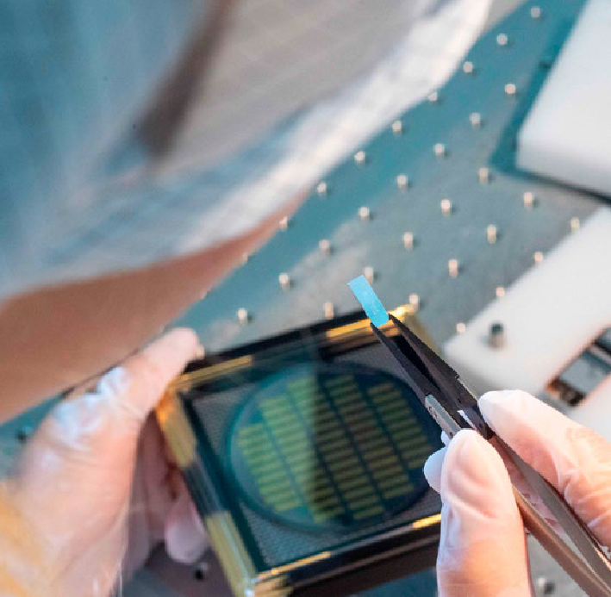ing an ambitious package of measures as part of the fiscal stimulus and future package, the aim of which is to achieve technological sovereignty for Germany and Europe in the field of quantum computing. This would mean that Germany, together with partners from the European Union, becomes technological-ly independent when it comes to the production of

corresponding hardware and software. A central role in critical elements of international value chains for quantum computing can also ensure that Germany, as a key partner, can always maintain access to econom-ically essential quantum resources. A balance must be struck between competition and cooperation.

In the short and medium term, the measures aim to develop the first quantum computers in Germany at the state-of-the-art in research and technology. They are to be scaled up and improved until they provide a quantum advantage in practical applications. This forms the basis of the development of a universal, error-corrected system. The Federal Government is

relying on a technology-open approach in this respect, since it is not yet foreseeable which technological

basis is best suited for the various areas of applica-tion and which can be scaled up. We regularly review which of the technology strands seems promising and adjust the portfolio of measures accordingly.

As part of this conceptual framework programme the Federal Government aims to develop a quantum

1. Kagermann, H./Süssenguth, F./Körner, J./Liepold, A.: [The Innovation Potential of Second-generation Quantum Technologies](https://www.acatech.de/publikation/innovationspotenziale-der-quantentechnologien/) (acatech IMPULS), Munich 2020
2. Federal Office for Information Security BSI: [Status of quantum computer development](https://www.bsi.bund.de/EN/Themen/Unternehmen-und-Organisationen/Informationen-und-Empfehlungen/Quantentechnologien-und-Post-Quanten-Kryptografie/Entwicklungsstand-Quantencomputer/entwicklungsstand-quantencomputer_node.html) (2020)
3. VDI Technologiezentrum GmbH: Roadmap Quantencomputing (2021)
4. Bundestag printed papers 19/25208 and 19/26340
5. IBM: [The IBM Quantum Development Roadmap](https://www.ibm.com/quantum/technology) (2022)
6. D-Wave: [Clarity. A roadmap for the future of quantum computing](https://www.dwavesys.com/media/xvjpraig/clarity-roadmap_digital_v2.pdf) (2021)
7. Google Quantum AI: [Unveiling our new Quantum AI campus.](https://blog.google/technology/ai/unveiling-our-new-quantum-ai-campus/) In: The Keyword (2021)

TOP-LEVEL TECHNOLOGY FOR CREATIVE POWER AND TECHNOLOGICAL SOVEREIGNTY **26**

computer on a par with international developments and at least 100 individually controllable qubits by 2026, scalable to 500 qubits in the medium term. In addition, high-performance special hardware shall be developed for suitable fields of application.

The work in hardware development is flanked by measures to develop software and algorithms for these new types of computers in order to be able to ex-ploit speed and quality advantages. This is particularly important in view of the fact that experts regard the decisive potential for value creation to not be in hard-ware and software, but in the next wave of digitisation and therefore in the applications.43 In parallel, quan-tum simulators are being further developed. These can provide similar quantum benefits to quantum computers in several specific areas, for example, in materials research or in the improvement of chemical processes such as the energy-intensive production of fertilisers.44

Specifically, the Federal Government is pursuing the following measures for the development of quantum computers ‘made in Germany’:

* + Competitive development of basic technology plat-forms for quantum computers. Within the frame-work of research projects, there is public funding for the development of hardware components as well as their design and implementation in demon-stration set-ups based on the various technology platforms.
  + In parallel the industrialisation of technically more mature technologies is taking place within the framework of contracts, in particular through DLR’s quantum computing initiative.
  + Establishment of a network for quantum al-gorithms and software. Here, the focus is on industry-specific applications that address opti-misation problems and procedures that look in particular at searches within large data pools.
  + Development of enabling technologies: in addition to the fundamental technological developments of quantum computing, suitable technical equipment

is needed, among other things, to control the sensi-tive quantum states.

* + Development of metrological foundations for the comparability of quantum computer hardware, such as the reliable measurement of qubit proper-ties, coherence times, etc.
  + Support to develop skilled workers: the aim is to use outreach activities to increase interest in quantum technologies in schools, to get students excited about the field and to develop support formats

for both academic and career paths in industry. Tailor-made programmes at postgraduate level help to train qualified specialists for the development of quantum technologies.

* + Support for spin-off companies from universities and research institutions. The goal is to build a ho-listic, internationally competitive, entrepreneurial ecosystem for quantum technologies.

1. Kagermann, H./Süssenguth, F./Körner, J./Liepold, A.: [The Innovation Potential of Second-generation Quantum Technologies](https://www.acatech.de/publikation/innovationspotenziale-der-quantentechnologien/) (acatech IMPULS), Munich 2020
2. Kagermann, H./Süssenguth, F./Körner, J./Liepold, A.: [The Innovation Potential of Second-generation Quantum Technologies](https://www.acatech.de/publikation/innovationspotenziale-der-quantentechnologien/) (acatech IMPULS), Munich 2020

## Create excellent framework conditions for a strong ecosystem

### Create interfaces: strengthen ecosystems

In order to make the new technologies application-ready and therefore usable within the economy and society, it is necessary to build a functional, compre-hensive ecosystem. This includes fundamental re-search, technology developments for users, the train-ing of technical specialists or experts in engineering sciences, computer science and physics, as well as additional support measures for networking and the development of a metrological quality infrastructure.

Germany introduces a number of strong players in all relevant areas. The Federal Government’s goal is to create close networking throughout all parts of the value chain in the form of an entrepreneurial ecosys-tem. This should enable the targeted and, by means of synergies, efficient development of quantum technol-ogies that are economically self-sustaining in the long term.

The Federal Government is strengthening the quan-tum technology ecosystem through the following means:

* + - Direct project funding from the Federal Gov-ernment is generally directed at consortia from industry and science. Project consortia that cover as many parts of the value chain as possible are funded. Through joint research and development work, close ties are forged between fundamental researchers, developers and users, and ideas are pursued in a targeted manner. The development of characterisation, qualification and standardisa-tion of quantum technology components within value chains is considered from the beginning and included in the measures.
    - At the same time the entrepreneurial ecosystem is stimulated by collocated research contracts: for example, innovative quantum computers are procured for DLR’s own needs through research

contracts. In the European partnership EuroHPC, which is co-financed by the Federal Government,

quantum computers are also being procured for locations of the Gauss Centre for Supercomputing in Germany; albeit with a smaller financial volume.

With this instrument, more mature approaches in technological terms will be developed in the medium term by companies, especially start-ups.

For highly innovative companies from the Europe-an economic area, close cooperation with DLR also creates incentives to locate research, development and production in Germany.

* + Focused networking meetings, seminars and sym-posia work alongside the research and development activities within the technology strands, enabling exchange and synergies across individual project consortia. Complementary to this and with the goal of creating a powerful ecosystem, is the provision of overarching exchange forums and seminars, the preparation of an accompanying analysis of the ecosystem and discussions about cross-cutting issues in joint workshops. This also ensures that synergies are created and the resources deployed are used efficiently.

### Strengthen start-up culture and innovative companies

Start-ups and small and medium-sized enterprises with strong research capabilities will play an impor-tant role in technology development, while coopera-tion models with large companies have also proven to be successful in this regard.

The Federal Government supports young, innovative companies with this through:

* + Specific funding that allows spin-offs from uni-versities and research institutions in the field of quantum technologies to transfer innovative ideas and move towards application and commercial exploitation,45
  + The expansion of technology transfer in all facets at the level of institutional and strategic development of publicly funded research institutions, especially through spin-offs,

1. BMBF funding guideline [Enabling Start-up: Unternehmensgründungen in den Quantentechnologien und der Photonik](https://www.quantentechnologien.de/forschung/foerderung/enabling-start-up.html)

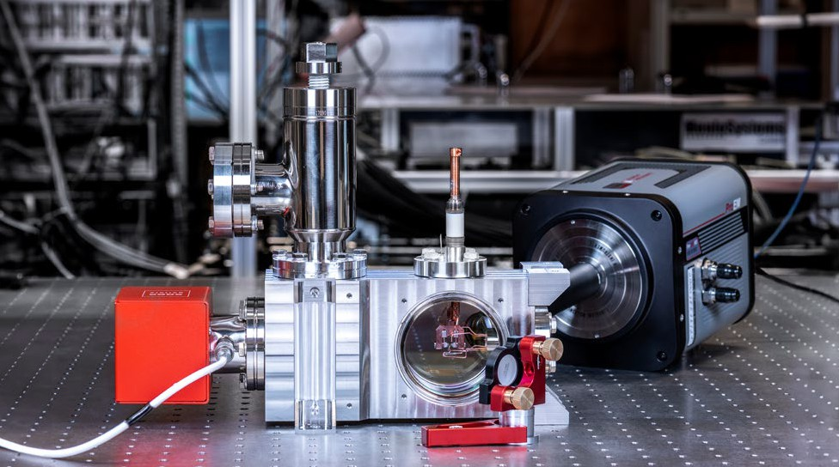

* + Specific promotion46 and targeting of small and medium-sized enterprises,
  + The facilitation of access, especially for young companies, start-ups and small and medium-sized enterprises, to existing quantum technology exper-tise and infrastructure at universities and research institutions. This is particularly necessary in the deep-tech field of quantum technology in order to effectively translate Germany’s excellent starting position in research into applications and to bring it to market.47, 48
  + Networking with public venture capitalists (espe-cially High-Tech Gründerfonds, DeepTech & Cli-mate Fonds, Federal Agency for Disruptive Innova-tion SPRIN-D) as well as long-term oriented private investors who are loyal to the location.

**Awaken interest, attract skilled workers** Quantum technologies are still a comparatively ab-stract topic that requires explanation, with communi-cation proving to be a major challenge. For a discus-sion of the technology and its applications, however, an approach is required that can be understood in general terms. In addition, there is a need for realis-

tic expectations regarding the potential, the pace of development as well as the limits of the technology, especially among decision-makers from business and politics. Information that can be understood by all parties concerned and specific knowledge about ap-plications of quantum technologies are therefore also needed in general and school education.

Bottlenecks in recruiting suitable academic special-ists are already becoming apparent today.49 Con-sequently, it is hugely important to look at ways in which information can be shared in a manner that is appropriate for the target group. The aim is to

increase low-threshold interest in order to inspire the skilled workers of tomorrow, as well as to demonstrate potential to users from outside the field. Employees in companies must be empowered to use the technology. And it goes without saying that there is also a need for highly qualified professionals, especially with regard to developing the technology further. For this reason, the following needs to be done:

* + Showcasing of opportunities and possibilities for different professional development paths,

1. BMBF Funding guideline [KMU innovativ: Photonik und Quantentechnologien](https://www.quantentechnologien.de/forschung/foerderung/kmu-innovativ-photonik-und-quantentechnologien.html)
2. Kagermann, H./Süssenguth, F./Körner, J./Liepold, A.: [The Innovation Potential of Second-generation Quantum Technologies](https://www.acatech.de/publikation/innovationspotenziale-der-quantentechnologien/) (acatech IMPULS), Munich 2020
3. McKinsey & Company: [Quantum Technology Monitor](https://www.mckinsey.de/%7E/media/mckinsey/business%20functions/mckinsey%20digital/our%20insights/quantum%20computing%20funding%20remains%20strong%20but%20talent%20gap%20raises%20concern/quantum-technology-monitor.pdf) (accessed on 22.11.2022)
4. McKinsey & Company: [Quantum Technology Monitor](https://www.mckinsey.de/~/media/mckinsey/business%20functions/mckinsey%20digital/our%20insights/quantum%20computing%20funding%20remains%20strong%20but%20talent%20gap%20raises%20concern/quantum-technology-monitor.pdf) (accessed on 22.11.2022)
   * + 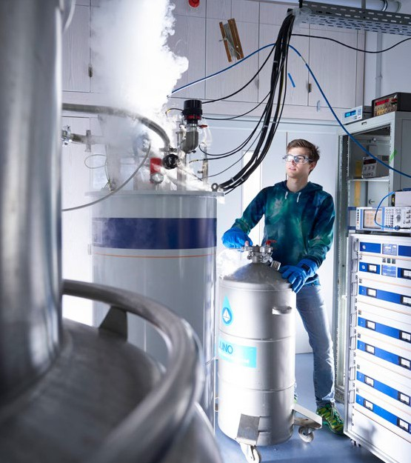Analysing the needs of developers and users of quantum technologies in Germany within the con-text of an evidence-based education and research policy, as well as relevant capacities in terms of specialist training so that the scope of the necessary measures can be estimated,
     + Facilitation of access to quantum technologies in disciplines outside of physics, especially in related fields such as computer science and engineering,
     + Provision of support for the education and training of specialists in quantum technologies. There is a particular focus on the qualification of profession-als with practical experience.

The Federal Government has already put together a broad package of measures. Under the umbrella

brand *Quantum Future,*50 various measures are being put in place to build up a skilled labour base: young researchers can establish their first small working group, training and further education concepts are

actioned, younger students become enthused about the topic within the framework of an academy and an award ceremony. Intuitive and participatory outreach concepts for quantum technologies are also intended to address broader segments of the population.

Within the framework of this conceptual framework programme these measures will be developed further alongside new ideas for knowledge transfer and the participation of civil society. The biggest challenge

in the future will be to address and reach the differ-ent target groups. Only then will there be enough skilled workers for tomorrow, the right decisions will be made in dealing with the issue and the topic will become accepted on a social level.

One focus of the activities will be on increased support for excellent young personnel. This will begin with the networking of outstanding students and specific support for doctoral students, and will move on to targeted measures such as *Quantum Fellowships* or academic junior research groups for outstanding postgraduates who are urgently needed

for technology development in particular. In addition, specific attention will be paid to young people who can provide the next generation of skilled workers in the emerging quantum technology market. To this end age-appropriate ways of sharing research-based learning that will encourage people to act upon it are being developed, for example, through participatory actions in schools.

At the same time the further training of experienced professionals and technical staff from thematically related fields should be encouraged since this area is seen as being able to offer particularly good prospects for broadening the skilled labour base.51

### Keeping an eye on impact: identifying opportuni-ties and considering effects

To build a technology of the future, new develop-ments must be recognised at an early stage and strategically taken into account. The Federal Govern-ment bases its measures on the results of broad-based agenda and strategy processes involving experts from

1. BMBF initiative [Quantum Futur](https://www.quantentechnologien.de/nachwuchs.html)e
2. McKinsey & Company: [Quantum Technology Monitor](https://www.mckinsey.de/%7E/media/mckinsey/business%20functions/mckinsey%20digital/our%20insights/quantum%20computing%20funding%20remains%20strong%20but%20talent%20gap%20raises%20concern/quantum-technology-monitor.pdf) (accessed on 22.11.2022)

science and industry.52, 53 In addition, the positions of expert commissions,54 academies55 and associations56, 57 are also taken into account.

Due to the rapid development of the technology, the Federal Government is also in constant dialogue with the professional sector in order to be able to take new developments into account at an early stage. For this purpose, the opinion of expert committees with ex-ternal expertise is sought, partly through fixed advi-sory groups and partly through expert discussions on specific topic areas. In addition, a systematic, ongoing monitoring of the ecosystem will be set up as part of the accompanying research.

At the same time the buy-in of citizens regarding the acceptance of new quantum technologies must take place alongside technology development. Direct and early cooperation between researchers and later users within the framework of participatory technology development will promote practical and needs-oriented technical solutions. From coming into direct contact with new quantum technologies in medicine, mobility and communication, to questions of resil-ience and internal and external security, citizens and the economy, the state and society will be impacted in many ways by these new developments. So far,

the discussion has focused on the opportunities and options provided by the technology. The risks that are currently most frequently under discussion come in the form of which development gaps exist compared to competing countries. However, as technologies mature and are applied, questions will increasingly be asked about societal and cultural influences, tech-nology assessment and the prevention of adverse side effects.

In addition to overall societal issues looking at social effects through the impact on everyday life and the world of work, discussions in the field of innovation management, for example, will focus on the impact of access to quantum technologies (e. g., through small and medium-sized enterprises), what effect quantum

technologies have on individual industries and supply chains or on national security provision, and what specific innovations they introduce.

Last but not least quantum technologies will have a considerable influence on modern cryptography.

As soon as powerful quantum computers become available, the security of cryptography methods used as standard today will no longer be guaranteed. Quan-tum communication can solve this problem through quantum-based key agreement.58 In combination with post-quantum cryptography based on mathematical principles, the confidentiality of sensitive information can be maintained in the long term. However, the new risks posed by technology, especially for information security and data protection, need to be evaluated, tracked alongside evolving technology, and effective countermeasures need to be designed.

Overall, it is important to keep an eye on any such consequences at an early stage in order to counteract potentially undesirable developments promptly and in order to hold an open discussion with the social actors.

1. VDI Technologiezentrum GmbH: [Roadmap Quantencomputing](https://www.quantentechnologien.de/service/publikationen.html) (2021)
2. VDI Technologiezentrum GmbH: [Roadmap Quantencomputing](https://www.quantentechnologien.de/service/publikationen.html) (2021)
3. Commission of Experts for Research and Innovation (EFI): [Report on Research, Innovation and Technlogical Performance in Germany 2022](https://www.e-fi.de/en/publications/reports) (2022)
4. Kagermann, H./Süssenguth, F./Körner, J./Liepold, A.: The Innovation Potential of Second-generation Quantum Technologies (acatech IMPULS), Munich 2020 and McKinsey & Company, [Quantum Technology Monitor](https://www.mckinsey.de/~/media/mckinsey/business%20functions/mckinsey%20digital/our%20insights/quantum%20computing%20funding%20remains%20strong%20but%20talent%20gap%20raises%20concern/quantum-technology-monitor.pdf) (accessed on 22.11.2022)
5. Federation of German Industries (BDI): Europa zum führenden Standort für Quantentechnologien entwickeln (2021)
6. Bitkom: Leitfaden Quantentechnologien in Unternehmen (2022)
7. Deutsche Bank Research: [Economic-technological revolution through Quantum 2.0: New super technologies are within reach](https://www.dbresearch.de/PROD/RPS_EN-PROD/PROD0000000000435629.alias?ElementKey=PROD0000000000521324&ExcludeIssue=PROD0000000000521324&PageTitle=89ozIF%2FYTSLX55CAXGgJCdwJbiAxxabFrcbBAgh0szrjwzwReHffGgTnDqeBmVISXL2nqcbSzuu6LKoMgnfOgPq%2BSIw4NKvmYk2nR6RO2j2qrMSWxpCC3isGR4JcuH1da75p38MNbIPYPkMF50IxQ15qK6feGlDJB6%2F64fiLwyCQFcdzi2eH3Q%3D%3D&ColumnViewRwdFree=AT%2CDU2%2CTI%2CDA%2CT3%2CT1%2CT2%2CPE%2CNR%2CTE%2CDU1&Hits=12&ColumnViewRwdStyle=gmlist4&LayoutTypeResult2=rpsResultAndFilter) (2021)

## Joint action by the Federal Government

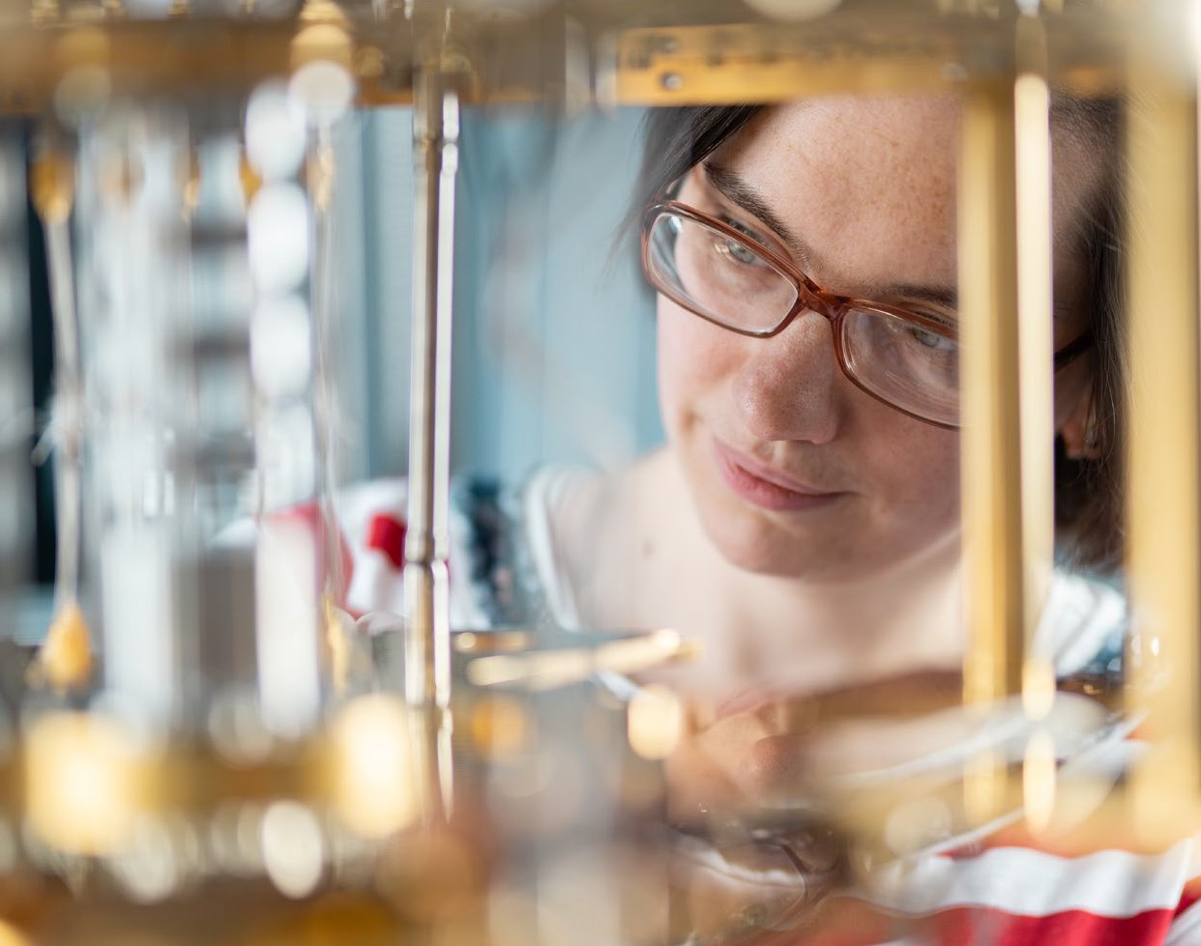

4. Acting together – securing sovereignity

The Federal Government jointly coordinates its measures in quantum technologies at various levels in an inter-ministerial manner. The aim is to avoid duplication of work, to define interfaces as well as handover points and to bring together development strands beyond the respective areas of responsibility of the ministries.

The activities of the ministries are considered together from the outset and regularly coordinated at a man-

agement and working level. The central committee at the working level is a ministerial group in which

all thematically involved ministries work together on current developments and planned measures.

In addition, within the framework of project fund-ing, activities are coordinated jointly and at an early stage in order to create synergies. This includes joint, inter-ministerial activities to strengthen ecosystems and networking between different funded actors.

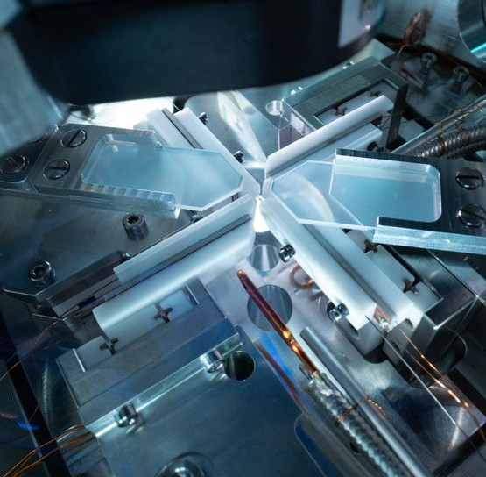With increasing technological progress and applica-tion coming ever nearer, the Federal Government ex-pects the commercial sector to gradually assume in-creasing responsibility for the ecosystem and research and development activities. The Federal Government will support this development with accompanying analyses and adapt and further develop its measures on this basis.

## Interdisciplinary interfaces

The interdisciplinary field of quantum technologies has points in common with several other key emerg-ing technologies. It is also important to be able to connect to existing technologies, for example, the embedding of quantum computing in the infrastruc-tures of ‘high-performance computing’ (HPC), the creation of ‘software stacks’, or the embedding of quantum communication in modern information and communication technology, especially at the interface with artificial intelligence. In addition, further devel-opment also requires technological advances, for ex-ample, in the field of microelectronics, photonics and cryotechnology. This anchoring is ensured through joint projects in interfaces and the position it takes up in the relevant research programmes. Consequently, there are overlaps with various other programmes

of the Federal Government or individual ministries, for example, in the field of microelectronics, high-performance and supercomputing, cyber and IT security or space research (see also Annex ‘Ministerial research programmes, strategies and measures with reference to the conceptual framework programme’).

## Network with national actors

The measures are closely linked to the activities of institutions funded by the Federal Government who are active in the field of quantum technologies. An overview of the measures taken by these institutions is provided in the annex.

In Germany there are strong regional centres that are supported by targeted actions taken by their respec-

tive federal states. Close networking of the Federal Government with the specific measures and priorities of the federal states is ensured by regular coordina-tion meetings at working level. In addition, significant momentum can also result from close contact with academies and associations.

## Build strong international partnerships and secure technological sovereignty

The Federal Government’s goal is to ensure sover-eignty in terms of access to all the relevant building blocks of this future technology. This goal is pursued by holistically promoting an entrepreneurial quan-tum technology ecosystem and helping to shape its development and application by providing an equal footing and ensuring it remains in line with our val-ues. In doing so the German government is relying on a strategic European approach with the political goal of technological sovereignty.59

European actions dedicated to quantum technolo-gies have been collated at European level since 2018, mainly through the *Quantum Flagship*, which was supplemented, for example, by European funding for

1. Federal Ministry of Education and Research BMBF: [Technologisch souverän die Zukunft gestalten](https://www.bmbf.de/SharedDocs/Publikationen/de/bmbf/5/24032_Impulspapier_zur_technologischen_Souveraenitaet.html) (2021)

metrological aspects under the *Euramet* framework.60, 61 Now that the ramp-up phase of the flagship project has been completed, the course for successful imple-mentation needs to be set. To this end the *Horizon Europe* and *Digital Europe* programmes support research and development as well as the development of infrastructure. Networking between national and European funding measures takes place at different levels. For example, the *QuantERA* initiative supports transnational funding projects. There is also close coordination with the EU Commission, ESA and

other EU member states, while the pooling of national and European funds for larger structural measures takes place, such as the pan-European procurement

of quantum computers and their integration into an HPC environment in EuroHPC62 or the establishment of a European quantum communication network *(EuroQCI)*63 and its space component SAGA. Further-more, the *Framework Partnership Agreement* for ‘open testing and experimentation’ was launched, which aims to bring together European testbeds on quantum technologies.64 In the field of standardisation, the publication of the roadmap on standardisation needs of the European CEN-CENELEC is expected.65, 66

Specifically in terms of technological sovereignty, it is important that close coordination with European

partners continues. Especially in quantum computing and quantum communication, the aim is to achieve

a leading position with European partners in terms of global competition and to position Europe as a technology provider. This should also prevent Europe from falling into critical dependencies.67

The German government is strengthening these European initiatives through targeted bilateral and multilateral activities with partners. A prerequisite for these initiatives is that they

* allow cooperation by ensuring they meet our values and take place on a level playing field,
* are conducive to the goal of technological sover-eignty, and
* are on the basis of mutual added value of coop-eration through the complementary addition of competences and technologies.

In combination with national and European activities, it is possible to engender targeted momentum and thereby strengthen the ecosystem.

In addition to the targeted strengthening of collabora-tions, the danger of expertise exiting to non-European countries must also be taken seriously. Against this context the Federal Government is pursuing vari-

ous approaches in its measures to prevent the loss of technological expertise in this technology of the

future, for example, through the instrument of back-licensing for contractors within the framework of the DLR’s Quantum Computing Initiative, through cor-responding project funding regulations and through measures within the framework of foreign trade law.

1. Degiovanni, I. P. et al.: [EUROMETEMNQ: The European metrology network for quantum technologies.](https://www.sciencedirect.com/science/article/pii/S2665917421003111) In: Measurement: Sensors 18 (2021)
2. [EURAMET – The European Association of National Metrology Institutes](https://www.euramet.org/about-euramet)
3. The European High Performance Computing Joint Undertaking EuroHPC JU: [New calls: The first EuroHPC quantum computers and upgrades to existing](https://eurohpc-ju.europa.eu/new-calls-first-eurohpc-quantum-computers-and-upgrades-existing-eurohpc-systems-2022-03-31_en) [EuroHPC systems](https://eurohpc-ju.europa.eu/new-calls-first-eurohpc-quantum-computers-and-upgrades-existing-eurohpc-systems-2022-03-31_en) (2022)
4. European Commission: [The European Quantum Communication Infrastructure Initiative EuroQCI](https://digital-strategy.ec.europa.eu/en/policies/european-quantum-communication-infrastructure-euroqci)
5. Examples are the European consortia within the framework of the Framework Partnership Agreements [Qu-Test](https://ec.europa.eu/info/funding-tenders/opportunities/portal/screen/how-to-participate/org-details/999999999/project/101080035/program/43108390/details) and [Qu-Pilot](https://ec.europa.eu/info/funding-tenders/opportunities/portal/screen/how-to-participate/org-details/999999999/project/101079926/program/43108390/details)
6. Liao, S.K. et al.: Satellite-relayed intercontinental quantum network. In: Physical Review Letters 120 (2018)
7. [CEN and CENELEC Joint Technical Committee 22 (CEN/CLC/JTC 22)](https://www.cencenelec.eu/areas-of-work/cen-cenelec-topics/quantum-technologies/); van Deventer, O. et al: [Towards European Standards for Quantum Technologies.](https://arxiv.org/abs/2203.01622)

In: EPJ Quantum Technology 9 (2022); ETSI Industry Specification Group (ISG) on Quantum Key Distribution (QKD) 67 European Commission: [European Chips Act](https://commission.europa.eu/strategy-and-policy/priorities-2019-2024/europe-fit-digital-age/european-chips-act_en) (2023)

**The success of the conceptual framework programme is measured by milestones, which at research policy level serve as target achievement control. They are regularly reviewed and, if necessary, adapted to the dynamic devel-opment of the international research field. By the end of the conceptual framework programme’s term in 2026, the following milestones should have been reached in Germany, depending on the technology level:**

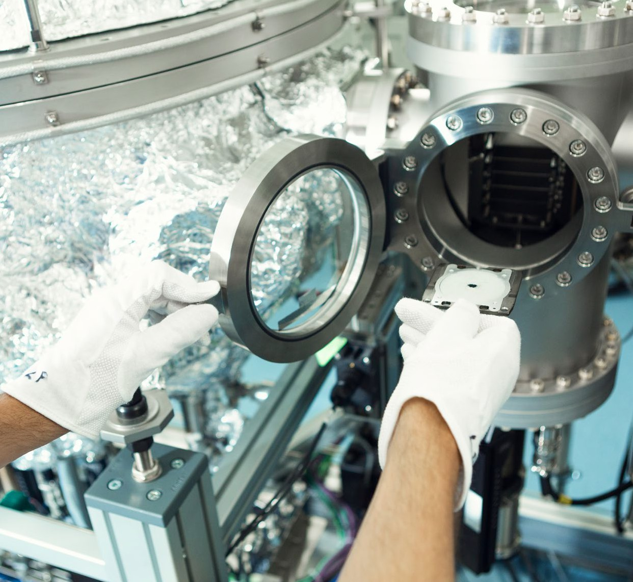

5. Milestones and resource planning

### Parametric source for entangled photons. Quantum computing

The goal is for Germany to catch up in technological terms with the leading players in quantum computing outside the EU. This is primarily about competitive-ness in a purely technical sense, such as the availa-bility of quantum hardware, its performance and an estimate of its potential for scaling, error rates and error correction. Measurable technological goals in 2026 include:

* + Availability of a quantum computer on a par with international developments and at least 100 indi-vidually controllable qubits, scalable to 500 qubits.
  + Development of high-performance special hard-ware for suitable application fields of quantum computing.
  + Furthermore, the techno-economic development of the entrepreneurial ecosystem for quantum com-puting in Germany should be among the top three within the EU and as a minimum, should, together with its European partners, attain the same level

as important non-European industrialised coun-tries such as the USA or Japan. Related quantitative indicators include:

* + - turnover, number of employees and profitability cumulated across the companies in the German ecosystem
    - development of the number of patents related to quantum computing by companies in the eco-system and by German research institutions
    - degree of coverage of quantum-computing-relevant technology branches by companies in the ecosystem
    - In addition, the extent to which networking takes place between companies in the ecosystem is to be recorded in the sense of how many com-panies or scientific partners work cooperatively on average, or what other economic networking takes place such as equity investments, spin-offs, etc. The number of companies in the ecosystem is to be determined.
  + At least 60 end users are active in quantum comput-ing in Germany, including in business, science and civil society.

### Quantum sensor technology

With regard to quantum sensor technology, the Feder-al Government wants to put promising technological developments into use in the economy, society and in governmental institutions. In 2026 the following level of development should be attained in Germany:

* Five new products in quantum sensor technology on the market
* Optical clocks that meet the requirements of the next generation of Galileo clocks.

### Quantum communication and post-quantum cryptography

In terms of quantum communication and post-quantum cryptography, the Federal Government wants to achieve the following milestones by 2026:

* Establishment of the first tap-proof, i.e., quantum-encrypted, communication test routes between selected authority locations.
* Additional start-ups/companies founded in the field of quantum communication in Germany.
* Realising a nationwide fibre optic backbone for quantum communication and time and frequency distribution.
* Demonstration of first quantum repeater test tracks.
  + Launch of first test satellites for quantum key dis-tribution.

**Resource planning**

In total, budget funds amounting to approximately EUR 2.18 billion have been earmarked in the cur-rent financial planning for the further development of quantum technologies in participating minis-tries during the term of the conceptual framework programme. The measures are complemented by the activities of science organisations institutional-ly co-financed by the Federal Government, which plan to invest approximately EUR 850 million into research on quantum technologies during this period.

All measures emerging from the strategy will be taken in accordance with constitutional areas of responsibility and are subject to funding approval. Where specific measures or future measures that build on such measures result in expenditure from the federal budget, they are subject to the proviso that sufficient federal funds are available and suffi-cient positions filled, and that they do not prejudice any current or future budgetary negotiations. The ministries support the implementation of the strat-egy in line with their responsibilities and financial resources. Financially and in terms of positions within the respective budgetary area, any addition-al requirements in terms of material and personnel resources must be counter-financed; additional funds are not available.

* + Creation of a Federal Government strategy for the migration to post-quantum cryptography in Germany.
  + Continuation of the migration to post-quantum cryptography for the high-security sector.
  + Initiate migration to post-quantum cryptography in further security-critical areas.
  + Integration of post-quantum cryptography meth-ods in practical IT security solutions.

For a subsequent transfer to productive systems, fur-ther stages will be required in relation to the testing, approval and technical upgrading of associated com-ponents and infrastructures.

### Characterisation and standardisation

In order to establish ‘made in Germany’ quantum technologies as a global mark of quality, the Federal Government is aiming, by 2026, to achieve the

* + Establishment of a quality infrastructure for quantum technologies for objective, independent characterisation, qualification and standardisation of quantum technology components and compara-tive benchmarks.

In addition, the impact of the Federal Government’s measures is tracked using overarching and topic-specific indicators; these are evaluated as part of assessments of the programmes upon which this conceptual framework programme is based (see also Annex).

## Ministerial research programmes, strat-egies and measures with reference to the conceptual framework programme

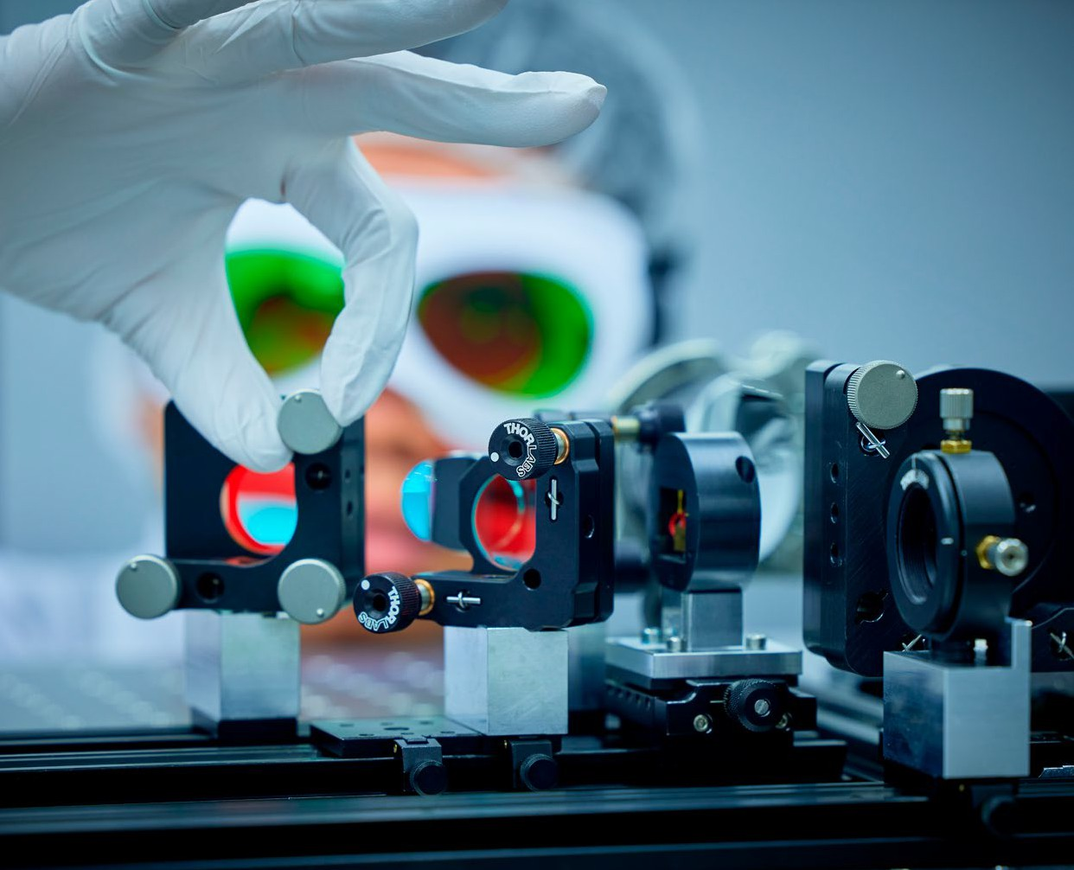

6. Annex

### Future Research and Innovation Strategy of the Federal Government68

The Future Strategy for Research and Innovation lays the foundations for Germany and Europe to play a decisive role in major research and innovation policy issues over the coming years. Using this as a basis, we

want to use impulses as well as experiences and to learn from the current crises in respect of them being drivers of change processes in society.

### Digital Strategy of the Federal Government69

The Digital Strategy brings together under one roof the Federal Government’s policy priorities on the cross-cutting issue of digitisation and forms the overarching framework for digital policy until 2025. The strategy provides an overview of the main digital policy projects that each ministry is responsible for implementing.

1. The Federal Government: [Future Research and Innovation Strategy](https://www.bmbf.de/bmbf/en/research/hightech-and-innovation/future-research-and-innovation-strategy/future-research-and-innovation-strategy.html) (2023)
2. Federal Ministry for Digital and Transport BMDV: [Digitalstrategie Deutschland](https://digitalstrategie-deutschland.de/static/fcf23bbf9736d543d02b79ccad34b729/Digitalstrategie_Aktualisierung_25.04.2023.pdf) (update 2023)

### BMBF Research Programme on Quantum Systems70

This research programme sets out the strategic frame-work for research funding by the Federal Ministry of Education and Research (BMBF) for future technolo-gies of photonics and quantum technologies over the next ten years. The funding is in line with the mission of the research programme: lead Germany to become the world leader in quantum sensor technology and quantum computing in the next decade as part of the European alliance and expand Germany’s competi-tiveness in quantum systems. The aim is also to secure technological sovereignty and to use the opportuni-ties offered by quantum systems to achieve a modern and sustainable economy and society.

**BMBF Research Programme on IT Security**71 Through the framework programme for research, technological development and demonstration activities, the Federal Government is strengthening excellent research for IT security and privacy and paving the way for economic prosperity and techno-logical sovereignty in Germany and Europe. Research funding for quantum communication is an important component of the Framework Programme. The goals with regard to quantum communication are primarily to improve the performance and robustness of quan-tum communication components and other security concepts based on quantum mechanics, to develop hybrid quantum communication systems based on various transmission and storage technologies, and

to further develop secure and efficient concepts for

quantum networks and their integration into existing traditional communication and IT infrastructures.

In order to meet the challenges of decryption posed by quantum computers, research is to be conduct-ed in parallel into how it is possible to migrate to

post-quantum cryptography. In addition, possible at-tack strategies on quantum information systems will be analysed and effective countermeasures developed.

### BMBF Research Programme on High Performance Computing72

With this programme the BMBF is funding inno-vations in high-performance computing and the expansion of computing infrastructure into the exascale range, driving applications in industry and strengthening high-performance computing at uni-versities. This is supported by research approaches to develop efficient and powerful hardware and soft-ware for future computer systems and applications. In order to bring new computing technologies such as quantum computing into use more quickly, they will be integrated into the existing ecosystem of high-performance computing. Furthermore, supercomput-ing centres, such as the sites of the Gauss Centre for Supercomputing, provide good conditions for inte-grating quantum computers.

**BMBF Research Programme on Microelectronics**73 There is an important technological and structural interface that is particularly present in the field of microelectronics, the promotion of which is an-chored in the framework programme. The traditional electronics addressed in this instance are important for enabling technologies, especially for the control of quantum computer chips. Process-wise there is also an overlap in the production of semiconductor-based quantum chips.

### Cyber Security Strategy for Germany 202174

The Cyber Security Strategy published in 2021 forms the strategic framework for the Federal Government’s actions in the field of cybersecurity for the next

five years. It describes the fundamental, long-term orientation of the Federal Government’s cybersecu-rity policy in the form of guidelines, areas of activity and strategic goals. It promotes action and is intended to shape future direction, enabling and promoting a targeted and coordinated interaction of all actors.

The Cyber Security Strategy for Germany and the cybersecurity strategies of the Federal States comple-ment each other and thus intensify federal coopera-tion. Embedded in the European Cybersecurity

1. Federal Ministry of Education and Research BMBF: [Forschungsprogramm Quantensysteme](https://www.quantentechnologien.de/service/publikationen.html) [Spitzentechnologie entwickeln. Zukunft gestalten.](https://www.quantentechnologien.de/service/publikationen.html) (2022)
2. Federal Ministry of Education and Research BMBF: Digital. Sicher. Souverän. – Forschungsrahmenprogramm der Bundesregierung zur IT-Sicherheit (2021)
3. Federal Ministry of Education and Research BMBF: [Hoch- und Höchstleistungsrechnen für das digitale Zeitalter. Forschung und Investitionen zum](https://www.bmbf.de/bmbf/de/forschung/digitale-wirtschaft-und-gesellschaft/supercomputing/supercomputing_node.html) [High-Performance-Computing](https://www.bmbf.de/bmbf/de/forschung/digitale-wirtschaft-und-gesellschaft/supercomputing/supercomputing_node.html)
4. Federal Ministry of Education and Research BMBF: Mikroelektronik. Vertrauenswürdig und nachhaltig. Für Deutschland und Europa. Rahmenprogramm der Bundesregierung für Forschung und Innovation 2021–2024 (2020)
5. Federal Ministry of the Interior and Community BMI: [Cyber Security Strategy for Germany](https://www.bmi.bund.de/EN/topics/it-internet-policy/cyber-security-strategy/cyber-security-strategy-node.html) (2021)

Strategy, the Cybersecurity Strategy for Germany also contributes to shaping Europe’s digital future.

**The Federal Government’s Space Programme**75 The BMWK supports German space research in research and development projects undertaken by German companies, research institutions and uni-versities via the Space Agency in the DLR on the basis of the *National Programme for Space and Innovation*. Over the past two decades, a high level of technology

#### [*PlanQK*](https://planqk.de/en/) *– Platform and Ecosystem for Quantum* assisted Artificial Intelligence

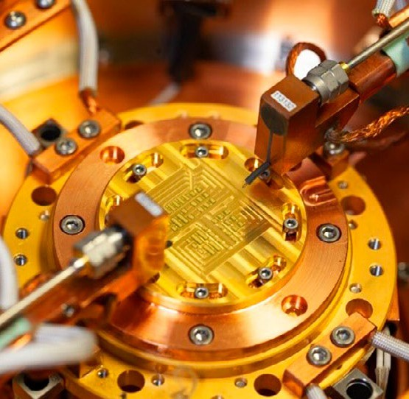With this technology programme, the BMWK sup-ports research, development and innovation projects that prove and demonstrate the technical feasibility and economic viability of quantum computing using the example of relevant, practical use cases, particu-larly in small and medium-sized enterprises. The quantum computing applications that are looked at include material simulation for hydrogen research, machine learning for the evaluation of used vehicles and the optimisation of processes in production and logistics. Furthermore, within the funding measures, foundations are also being developed for GDPR-compliant Cloud solutions for quantum computing carried out in Germany and Europe. In addition, the platform developed as part of the large-scale *PlanQK – Platform and Ecosystem for Quantum assisted Artifi-cial Intelligence* project already offers public access

to users and developers of software for quantum computing so that they can use and jointly implement quantum computing solutions. In total ten collabo-rative projects involving a total of 67 partners from industry and science are being funded with around EUR 50 million.

## Overview of activities of subordinate authorities, agencies and institutionally funded bodies

development expertise for space quantum technology

has been built up in basic research projects. The re-

sults and competencies are now being transferred into applications while expanding Germany’s leading role and tapping into the potential of quantum technolo-gy for satellite navigation (optical clocks and inertial navigation), satellite communication (quantum key distribution), earth observation (gravimetry/gradiom-etry) as well as automation technology and robotics (quantum computing to increase the autonomy of future space systems).

### Agentur für Innovation in der Cybersicherheit GmbH [cyber agency]

The cyber agency finances and promotes medium to long-term research projects with high disruptive potential in the field of cyber security and related

key emerging technologies. In this context the cyber agency should deliberately act in a risk-taking manner (open innovation and venture culture) and exhibit

a high level of technological ambition. The cyber agency is not an institution undertaking university research and does not conduct independent research within the framework of programmes and projects. Within the framework of its entrepreneurial and sci-entific freedom, it aims to advance topics of cyberse-curity and related key emerging technologies linked to internal and external security in a demand-oriented

1. Federal Ministry for Economic Affairs and Climate Action (BMWK): [Nationales Programm für Weltraum und Innovation](https://www.foerderinfo.bund.de/foerderinfo/de/foerderung/bund/mobilitaet/raumfahrt/raumfahrt_node.html)



and application-oriented manner, thereby contribut-ing to Germany’s technological sovereignty in cyber-space and the information realm.

Within the framework of the cyber agency’s current strategy (2022-2025), research projects to promote cyber security in the field of quantum technologies will also be tendered.

### Bundesamt für Sicherheit in der Information-stechnik [Federal Office for Information Security] (BSI)

The BSI recommended initial quantum-safe pro-cedures in March 2020 and issued more detailed assessments and recommendations for migrating to quantum computer-resistant procedures in its December 2021 guideline *Making cryptography*

*quantum-safe*.76 In the high-security sector, approved products are already available that have implemented processes that are resistant to quantum computing. In addition, the BSI is conducting projects to investi-gate the security of quantum key distribution, which should contribute to the development of trustworthy and secure products.

The BSI participates in the standardisation of the quantum-safe FrodoKEM and Classic McEliece pro-cedures as recommended by it at ISO/IEC. In October 2022, a Preliminary Work Item for the *Inclusion of key encapsulation mechanisms for PQC in ISO/IEC*

*standards* project was launched in ISO/IEC SC27 WG2 following a proposal from BSI. ISO standards for FrodoKEM and Classic McEliece should come out of this project.

In order to continue to monitor the state of research on quantum computers, the project *Laufende Aktu-alisierung der Studie Entwicklungsstand Quanten-computer [Ongoing update of the study on the state of development of quantum computers]* will carry out annual revisions over the next three years of the study entitled ***Entwicklungsstand Quantencomputer [State***

***of development of quantum computers]***, which was prepared in 2017 and has already been updated twice. In the first revision of the study, the NISQ (Noisy Intermediate Scale Quantum) area in particular is dealt with more intensively and developments in error correction are discussed. In addition, an extended understanding of operational criteria is to be gained and the descriptions of algorithms, error correction and platforms are to be updated. Once the revision

is complete, the new version will be available on the above website.

As part of the BSI *Sichere Implementierung einer allge-meinen Kryptobibliothek [Secure implementation of a general crypto library]* project, which was completed in 2017, a BSI development branch including detailed crypto documentation was created for the Botan crypto library. In the current BSI *Pflege und Weiter-*

1. Federal Office for Information Security (BSI): [Kryptografie quantensicher gestalten](https://www.bsi.bund.de/SharedDocs/Downloads/DE/BSI/Publikationen/Broschueren/Kryptografie-quantensicher-gestalten.html) (2021)

*entwicklung der Kryptobibliothek Botan [Maintenance and further development of the Botan crypto library]* project, a selection of procedures resistant to quan-tum computing is now being implemented in Botan, taking into account current developments in the NIST standardisation process and the BSI recommenda-tions. This is intended to create a crypto library, tested in accordance with the current state of knowledge, for the deployment and use of post-quantum cryptogra-phy for the purposes of promoting the widespread use of quantum computer-resistant cryptography.

In the current BSI *Integration von Post-Quanten Kryptografie in den E-Mail-Client Thunderbird [Inte-gration of post-quantum cryptography in the Thun-derbird email client project]*, end-to-end encryption (E2EE) that is resistant to quantum computing is being implemented using encrypted and digitally signed emails. For this purpose, the OpenPGP-based public key cryptography of the popular email cli-ent Thunderbird is extended using encryption and

signature methods from post-quantum cryptography. In addition to the implementation activities, a major part of the project is a corresponding draft on stand-ardisation in the form of an RFC Internet Draft, which is intended for submission to the OpenPGP working group of the Internet Engineering Task Force (IETF).

In the *Quantencomputerresistente Authentisierung für VS-IT-Systeme [Quantum Computer Resistant Authentication for VS-IT Systems]* feasability study, which will run until February 2023, the implications of authentication procedures that are resistant to quantum computing being placed in existing VS-IT systems and those that are under development, are all being investigated by an external contractor. The signature algorithms that currently form part of the NIST standardisation process and the products from manufacturers of VS IT recognised by BSI are all be-

ing taken into consideration. In particular, limitations such as the performance of the signature algorithms, crypto-agility as well as the migration capability

of the VS-IT systems are taken into account in this feasibility study.

In cooperation with the European Telecommunications Standards Institute (ETSI), the BSI has pushed ahead with the creation of an initial protection profile for quantum key distribution (QKD) modules in accordance with Common Criteria. The Protection Profile, which

is limited to taking into account prepare-and-measure protocols and point-to-point connections, is now available in a first version and is to be certified soon. It represents the first stage in achieving an evaluation methodology, but requires the development of further standards and background documentation until actual certification of specific products is possible.

Achieving a secure implementation of QKD proto-cols requires a solid understanding of the possible side-channel attacks on QKD modules, something that has already been demonstrated for many specific implementations. To this end the BSI has commis-sioned the preparation of a study that will present the scientific state of research on side-channel attacks

on QKD systems in a standard and complete manner. This is a first necessary step towards the creation of an evaluation methodology for QKD side-channel attacks.

In close cooperation with the Physikalisch-Technische Bundesanstalt [National Metrology Institute of Ger-many] (PTB), the BSI is involved in the coordination

of the BMBF-funded *Schirmprojekt Quantenkom-munikation Deutschland [Quantum Communication Germany]* umbrella project. The key goal of the *Quantum Communication Germany umbrella project* is to establish quantum communication as a technology that can be used in practice, is secure and commercially available in Germany and Europe. The BSI therefore focuses on taking aspects of information security (for example, the security of QKD protocols) into account at an early stage.

### Bundesdruckerei GmbH

Bundesdruckerei GmbH, including its subsidiary Maurer Electronics GmbH, is a leading German

high-tech security company headquartered in Berlin. Providing innovative solutions, products and tech-nologies ‘Made in Germany’, it protects identities and data. In this way it creates trust and legal certainty within digital society, enabling sovereign action to be taken by countries, companies and citizens in the analogue and digital world. As a company that is part of the Bundesdruckerei Group, it is able to draw on more than 250 years of experience, paving the way

to a secure digital future. Bundesdruckerei GmbH currently holds more than 4,100 national and inter-national patents, employs around 2,600 people and in 2021 generated sales of EUR 642 million.

Bundesdruckerei has been working on quantum technologies since the *PlanQK* and *PoQuiID* projects. Their interest in both projects was a proof-of-concept pertaining to application scenarios using the quan-tum computing capacities of project partners, which are currently being developed. In 2021, the Qu-Gov – *Quantum Technologies for the Federal Administration* project was also added as a result of a direct com-mission from the Federal Ministry of Finance. With this, a top-down approach was followed, in which proof-of-concepts or proof-of-values are developed for use cases taken from the sovereign-administrative environment and then evaluated in a platform-open

manner. By the end of 2024, quantum technologies for the federal (financial) administration will therefore be evaluated and researched, and initial use cases will be tested. The main topics are

* Quantum information and security,
* Quantum analytics, and
* Quantum-related (data) sovereignty.

The project works with partners from science, in-dustry, start-ups and administration and relies on a collaborative approach. The first partners have

already been found or are within the selection process. This project represents an interface between science, industry and administration and, therefore, regards itself as an enabler for a modern, future-oriented ad-ministrative structure, which ties in seamlessly with

digital topics such as the Federal Data Atlas and the Federal AI Competence Centre.

At that time, Bundesdruckerei, together with DB Sys-tel, founded the *Bundesquantenallianz* (BQA) in order to research quantum technologies that went beyond the scope of the project on behalf of the federal ad-ministration, together with federal or federal-linked companies. Currently, the BQA is in discussion with other federal institutions such as PTB or BAM. This federal quantum alliance is thus a useful addition

to the various ‘quantum alliances’ in Germany that have been shown to date, since it explicitly address-es companies and authorities owned by the Federal Government and can multiply the insights gained in

the *Qu-Gov* project. Further information can be found at [**bundesdruckerei-gmbh.de**](https://www.bundesdruckerei-gmbh.de/de).

### BWI GmbH

BWI GmbH, as a wholly-owned federal company, is the IT software house of the Bundeswehr. As a link between the military and industry, BWI operates and develops the IT used within the German armed forces, carries out digital transformation projects

and tests and implements innovative use cases. In the latter case in particular, BWI focuses on the early and application-oriented use of novel technologies. In this respect, BWI clearly distinguishes itself from research in its portfolio of services: BWI primarily builds on research results and enables their subsequent imple-mentation in practice. To this end the ‘Competence Centre Quantum Enabled Technologies’ was founded within the Innovation & Technology division of BWI.

Their stated aim is to raise awareness of quantum technologies in the BWI and Bundeswehr environ-ment. Market and technology screenings, knowledge transfer from consulting projects and individual trials are all used to draw up specific recommendations for action for BWI’s service portfolio.

### Deutsche Forschungsgemeinschaft e. V. [German Research Foundation] (DFG)

The DFG’s primary task is to promote cutting-edge, knowledge-driven research. The DFG is particularly active in those areas where research itself deter-mines the topics, following the dynamics of scientific knowledge processes. Eligible individuals, groups or institutions can therefore submit funding proposals to the DFG at any time and on any topic. The increas-

ing demand for both individual funding and coordi-nated programmes, and the associated increase in the volume of awards in the field of quantum technology, show that the DFG’s instruments are addressing needs across the entire spectrum of funding.

In 2021 a total of 149 projects carrying an annual funding amount of EUR 58.6 million directly related to the research field of ‘quantum technology’ were be-ing funded at the time. Of this, EUR 40.4 million was awarded to Clusters of Excellence.77 This corresponds to an increase of about 11% within three years.

Through coordinated programmes (Collaborative Research Centres, Research Training Groups, Clusters of Excellence), individual research areas are often strongly influenced by quantum technology, while the entire consortium tends to pursue fundamental research in natural sciences and engineering.

Over the course of its formative and strategic trading in the European Research Area, the DFG participates in the ERA-Net [***QuantERA***](http://www.quantera.eu/). The EU-funded association of 39 research funding organisations drawn from 31 countries supports research on quantum technologies, specifically through calls for transnational projects. In the last call for proposals, the DFG was responsible for funding participation from Germany in fundamental science-oriented projects. The 19 projects partly funded by the DFG will start in 2022. The next call for proposals, in which the DFG plans to participate, will take place in 2023.

Within the framework of two major research in-strumentation initiatives for research into quantum technology, which were launched in 2021, the DFG is providing support to eight universities through a total of approximately EUR 17.7 million. The aim of large-scale equipment initiatives is to make the latest tech-nology available for research. Two tenders were issued: *Spin-based quantum light microscopes* and *Quantum communication test environments* (QCDE).

In addition, the DFG has also been funding the Research Training Group [***Doctoral Experts in Photonic***](https://gepris.dfg.de/gepris/projekt/431314977?context=projekt&task=showDetail&id=431314977)[***Quantum Technologies***](https://gepris.dfg.de/gepris/projekt/431314977?context=projekt&task=showDetail&id=431314977)since 2021, the aim of which

is to establish a new professional group of ‘photonic quantum engineers’.

### Deutscher Wetterdienst [German Weather Service] (DWD)

Weather and climate simulations represent a primary use case for utilising high-performance computing (HPC) infrastructures due to their computing pow-er and storage capacity demands. With the *ICON-Consolidated* development line, the DWD and its partners from the ICON consortium (Max Planck Institut für Meteorology [MPI-M], German Climate Computing Center [DKRZ], Karlsruhe Institute of

Technologe [KIT)] are also preparing the *ICON* weather and climate model for future HPC architectures.

When the technology is sufficiently mature, this will also be completed for those architectures based on quantum computing. The expected extreme increase in computing power will allow even more accurate simulations of atmospheric processes to take place at a hitherto unprecedented resolution, while at the same time any uncertainties will be better qualified. Devel-opments in quantum computing for the application of solutions derived from mathematical equations, used to describe processes in the atmosphere, is therefore both very sensible and imperative.

### Cyber Defence and Smart Data Research Institute (FI CODE) at the University of the Bundeswehr Munich

The FI CODE has been an IBM Quantum Hub between 2018 and 2023 and is therefore one of very few to gain exclusive access to the IBM quantum computer infra-structure worldwide.

The current availability of small, noisy quantum com-puters therefore allows researchers at FI CODE to test quantum algorithms and heuristics, as well as error mitigation schemes, and to perform experiments to explore and apply quantum information processing.

1. The following Clusters of Excellence are very strongly linked to quantum technologies:
   * [*Complexity and Topology in Quantum Matter (CT.QMAT)*](https://gepris.dfg.de/gepris/projekt/390858490?language=en)
   * [*Light and Matter at the Quantum Frontier (QuantumFrontiers)*](https://gepris.dfg.de/gepris/projekt/390837967?language=en)
   * [*Advanced Imaging of Matter (CUI)*](https://gepris.dfg.de/gepris/projekt/390715994)
   * [*Munich Center for Quantum Science and Technology (MCQST)*](https://gepris.dfg.de/gepris/projekt/390814868)
   * [*Matter and Light for Quantum Information (ML4Q)*](https://gepris.dfg.de/gepris/projekt/390534769)

On the path to discovering the practical relevance of quantum computing, various applications in the areas of optimisation, machine learning and quantum sim-ulation are being pursued at FI CODE, in addition to the development of methods for circuit optimisation and error mitigation.

FI CODE intends to extend the cooperation with IBM as IBM Q Hub beyond 2023.

### Fraunhofer-Gesellschaft zur Förderung der ang-ewandten Forschung e. V. [Fraunhofer Society for the Promotion of Applied Research] (FhG)

The Fraunhofer-Gesellschaft is the world’s leading organisation for application-oriented research. Focus-sing on future-relevant key emerging technologies and on the utilisation of the results in business and in-dustry, it plays a central role in the innovation process.

Quantum technologies are currently in the crucial initial phase of the second quantum revolution, which will trigger disruptive changes in science, business and society. The Fraunhofer-Gesellschaft is meeting this challenge posed by quantum technologies in the following way:

* Based on its application expertise, the Fraunhofer-Gesellschaft identifies quantum added value in communication, computing, imaging and sensor technology, working closely with partners from industry.
* Using established technology platforms, the Fraunhofer-Gesellschaft enables a holistic approach
  + to the science of excellent fundamental research
  + and the economy regarding outstanding innova-tions in quantum technologies.
* In close cooperation with universities, the Fraunhofer-Gesellschaft qualifies graduates and existing specialists in the natural and technical sciences in an interdisciplinary and cosmopolitan manner and actively contributes to building com-munities.
* The Fraunhofer-Gesellschaft actively manages patent portfolios and promotes the establishment of companies in quantum technologies within the framework of the programmes of its centres of excellence.
* The Fraunhofer-Gesellschaft supports the devel-opment of technologies in the field of quantum computing, in particular by setting up a nationwide competence network for quantum computing

and within the framework of its cooperation with IBM Deutschland GmbH. It invests considerable resources of its own to make the system in Ehnin-gen available to the scientific community, industry, SMEs and start-ups, conducting research on it in the field of quantum computing – both alone and as a member of a consortium. A continuation of the cooperation with IBM beyond the current contract (02/2020–02/2024) is envisaged.

The Fraunhofer-Gesellschaft has been working inten-sively on this key emerging technology since 2016 and already provided funding for it in 2017 through the flagship *QUILT* project (focus on quantum imaging, with a high demand for scientific excellence and strong application potential), the first large-scale research activities.

Complementary to this the Fraunhofer-Gesellschaft provides the German R&D landscape with access to al-ready existing quantum computer including German/ European legal and data bases and data locality.

In the future the Fraunhofer-Gesellschaft will contin-ue to specifically promote the potential of quantum technologies in Germany and Europe, for which it particularly sees opportunities in the following areas:

* Targeted development of competence in systems to help shape a scientific & technological paradigm shift.
* Contribute to a sovereign, pan-European digital infrastructure with quantum-secured networks to protect state, industry & citizens’ rights and quantum-enabled computing capacity for R&D in energy, climate & health.
* Portfolio of IP rights & IP pooling for ‘freedom-to-move’ in Europe.
* Establish fabs & pilot lines for closed supply chains in a competitive & autonomous German-European economic area, including the Forschungsfabrik Mikroelektronik Deutschland (FMD) with the *Quantum and Neuromorphic Computing* module.

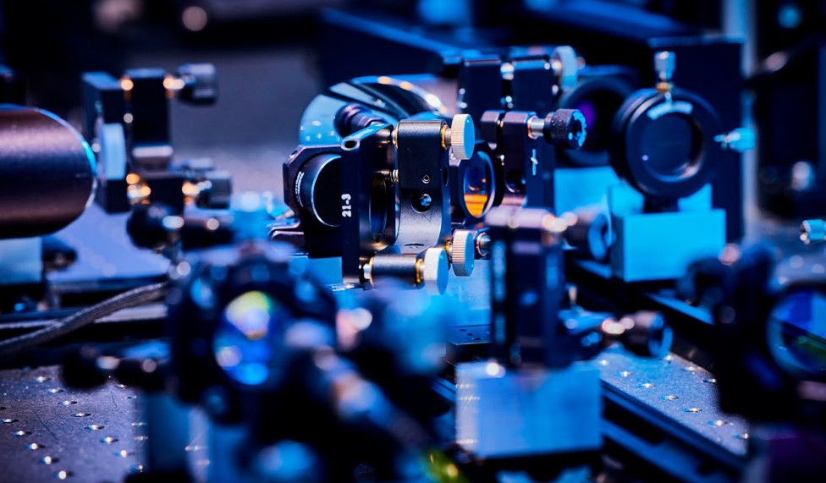

### Helmholtz-Gemeinschaft Deutscher Forschungszentren e. V. [Helmholtz Association of German Research Centres] (HGF)

The Helmholtz Centres that contribute to research in quantum technology78 are organised in the *Helmholtz Quantum* platform, which has published an overar-ching strategy for the Helmholtz Association.79 This identifies five quantum technology fields in which the centres, along with their research, contribute to dif-ferent focal points: 1. Quantum computing, 2. Quan-tum communication, 3. Quantum sensor technology,

1. Quantum materials and fundamental research, and
2. Quantum simulations and numerical methods.

Current research ranges from an understanding of fundamental quantum phenomena to the design of quantum states and the development of components for the realisation and deployment of fully functional devices as well as prototypes. The plan is to develop and provide infrastructures together with the user communities, including exchange platforms and qualification programmes, in order to increase poten-tial for the implementation of applications, co-design and future personnel. These include material charac-terisation platforms, quantum computers in high-

performance computing centres, and the development of a widely usable software package for quantum computing. Strong expertise in materials is necessary for excellent, disruptive technologies in the long term, while the integration of quantum computing into supercomputing centres ensures the full potential of quantum computing is made accessible, connecting to the user community at an early stage. Large software packages are now reaching the complexity of infra-structures and are a prerequisite for users. In the field of sensor technology, the stated goal is, among other things, the lab-on-chip integration of quantum sen-sors for application areas such as biology or medicine.

Together with partners from universities, research or-ganisations and industry, the Helmholtz Association aims to define far-reaching technological goals for the next 10 years and beyond, and to pursue them jointly at all levels, from fundamental science to systems engineering as well as applications.

Over recent years, further outstanding international scientists have been recruited for the communi-

ty. Many centres are establishing new institutes for research into quantum technologies and the commu-

1. German Electron Synchrotron (DESY), German Aerospace Centre (DLR), Jülich Research Centre (FZJ), GSI Helmholtz Centre for Heavy Ion Research (GSI), Helmholtz-Zentrum Berlin (HZB), Helmholtz-Zentrum Dresden Rossendorf (HZDR), Karlsruhe Institute of Technology (KIT)
2. Helmholtz Association of German Research Centres: [Researching the second Quantum Revolution](https://www.helmholtz.de/forschung/im-fokus/quantentechnologie/) (2021)

nity is investing in central infrastructures that will enable major advances as a technological hub. In the Helmholtz Association (as of 2021), there are already around 500 people working directly on research into quantum technologies. The researchers lead and par-ticipate in small and large projects that are funded, for example, by the BMBF, the EU or Helmholtz itself, and they are therefore closely involved in the national and European strategy.

Examples of specific goals for the next five years as formulated in the strategy paper:

* Systematic further development of promising scalable platforms for the realisation of multiple qubits in order to realise small-scale demonstrators beyond the state-of-the-art, with up to 100 qubits and low error rates for quantum computers and simulations.
* Development of easy-to-handle electrically oper-ated on-chip single photon emitters that operate at room temperature and in the telecommunications group.
* Robust and miniaturised optical quantum systems (lab-on-chip technologies) for high-precision space, time and acceleration measurements under harsh space conditions.80
* Exploring novel materials as a source for new metrological standards and innovative qubit concepts that go beyond current solid-state qubit systems. Creation of systematic multi-dimensional phase diagrams for material candidates in terms of electronic and magnetic properties, topology and potential functionality.
* Development of algorithms, methods and tools for disruptive computing devices intended to solve very difficult and previously unsolvable computing problems in science and industry.
* Research into the technological basis for a tap-proof quantum communication network in Germany and Europe.81

An additional contribution by DLR outside the programme-oriented research funding of the HGF is the DLR Quantum Computing Initiative, which has been funded with around EUR 740 million from the fiscal stimulus package for the construction of quan-tum computer systems, the development of software and initial applications. The initiative’s approach is to implement the systems by commissioning com-panies, especially start-ups. For this purpose, 80% of the funds flow into those companies that cover their full costs and can even achieve a profit margin. This

is particularly important for small and medium-sized enterprises or start-ups who have less financial power. The development of quantum computers for DLR’s research fields is therefore building up a parallel industrial ecosystem. At the same time the results (intellectual property) and co-determination rights in this potentially sensitive area of technology are to be secured for DLR, although the companies executing the work are to be given the freedom to act through a grant-back. In addition, co-location at the DLR insti-tutes in Hamburg and Ulm, among others, provides incentives for relevant, innovative companies from the European economic area to settle in Germany.

### Max-Planck-Gesellschaft zur Förderung der Wissenschaften e. V. [Max Planck Society for the Advancement of Science] (MPG)

The Max Planck Society (MPG) began funding basic research on quantum science and technology (QST) at an early stage in the spirit of the second quantum

revolution. In 1981, the Max Planck Institute (MPI) for Quantum Optics was founded in Garching, in 1993 the experimental branch of the MPI for Gravitational Physics was set up in Hanover, in 1994 it was the turn of the MPI for the Physics of Complex Systems in Dresden, and in 2009 the MPI for the Physics of Light in Erlangen. In addition, the Max Planck Institutes

for Solid State Research in Stuttgart, for Computer Science in Saarbrücken, for Nuclear Physics in Heidel-berg, for Multidisciplinary Natural Sciences in Göttin-gen, for Chemical Solid-state Physics in Dresden, for the Structure and Dynamics of Matter in Hamburg, for Microstructure Physics in Halle, for Mathematics in Science in Leipzig, for Intelligent Systems in Tübin-gen, for Security and Privacy in Bochum as well as the Fritz Haber Institute in Berlin also work in part on

1. German Aerospace Center DLR: [More accurate than ever – New clocks for the satellite navigation of the future](https://www.dlr.de/en/latest/news/2021/03/20210715_new-clocks-for-future-satellite-navigation) (15.07.2021)
2. German Aerospace Center DLR: [Erste quantengesicherte Videokonferenz zwischen zwei Bundesbehörden](https://www.dlr.de/de/aktuelles/nachrichten/2021/03/20210810_erste_quantengesicherte_videokonferenz_zwischen_bundesbehoerden) (10.08.2021)

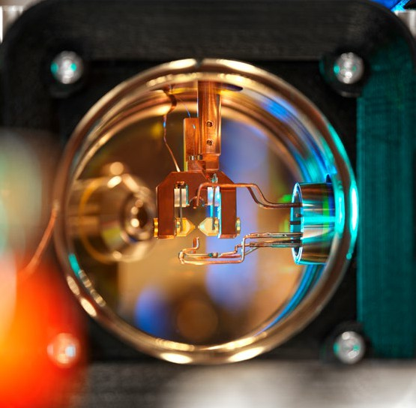aspects of this topic. With the fundamental research carried out on QST at all these institutes, the MPG sees itself as a pioneer and supporter of the current specialist programmes for quantum technologies.

The MPG regards QST as a strategically important topic, not only in terms of fundamental research, but also in terms of the potential economic benefits. Germany is excellently positioned when it comes to fundamentals and it can take up a leading role in the global competition for QST.

The MPG contributes central expertise in the area of QST, including in the following fields:

* + Quantum computing (Garching, Erlangen, Bochum, Tübingen)
  + Quantum simulation (Garching, Erlangen, Dresden, Hamburg)
  + Quantum cryptography, quantum communication, quantum internet (Garching, Erlangen, Bochum)
  + Quantum information theory (Garching, Leipzig, Saarbrücken)
  + Quantum sensor technology, quantum metrology, quantum imaging (Stuttgart, Hanover, Heidelberg, Garching, Göttingen)
* Quantum devices (Halle, Stuttgart, Dresden, Garch-ing, Erlangen)
* Quantum materials (Stuttgart, Hamburg, Halle, Dresden)

The MPG sees its contribution to the national strategy primarily within the context of the continuation and expansion of excellent fundamental research. This also includes opening up new subject areas, paying attention to the patenting of new ideas, promoting spin-off companies and start-ups, and participating in national and international research networks. The MPG makes essential contributions to the transfer

of fundamental phenomena of the second quantum revolution into application-relevant technologies.

For example, the MPG played a key role in the expert council that identified the central challenges in the field of quantum computing and issued recommen-dations for future action in the form of a national roadmap at the beginning of 2021.

The MPG has tightened up its strategy with regard to QST; extensive activities have been launched, both internally and externally, two of which are briefly explained below:

**Max Planck Quantum Alliance (MPQA)**

An important component of a sustainable long-term strategy for the MPG in the area of QST is the es-tablishment of an internationally visible umbrella organisation that unites the various activities (new and existing) within the MPG and provides a platform for the implementation of further measures. This *MPQA* initiative aims to increase the global visibility of the MPG in QST, to strengthen the collaboration within the MPG between the participating depart-ments in the field of QST, and to increase competi-tiveness in attracting top talent who are very much in demand internationally. As some of the QST research topics are located between the core areas of different institutes (especially with regard to scientific concepts and/or the required technological infrastructures), the interdisciplinarity of QST remains an ongoing challenge.

**Munich Quantum Valley (MQV)**

The MPG is a driving force behind the *Munich Quantum Valley* initiative, which aims to establish

quantum computing and quantum technologies in Bavaria as a unique network of its kind in Europe. The members of the initiative (the Bavarian Academy of Sciences and Humanities (BAdW), the Ludwig-Maximilians-Universität München (LMU), the Tech-nische Universität München (TUM), the Friedrich-Alexander-Universität Erlangen-Nürnberg (FAU), the

Fraunhofer Gesellschaft (FhG), the German Aerospace Center (DLR) and the MPG) signed the founding char-ter of the MQV Association on 27 January 2022. The Free State of Bavaria is supporting the initiative with EUR 300 million in funding from the *High-Tech Agen-da Bavaria* until 2025. In addition, there is more than EUR 80 million from funding programmes run by the Federal Ministry of Education and Research (from the Quantum Technologies Stimulus Package) and the Federal Ministry for Economic Affairs and Climate Action, which was obtained through the submission of joint applications from members of the initiative. More than 40 scientific institutions, research insti-tutes and companies have thus far joined forces under the umbrella of the *MQV*.

The main goal of the initiative is to establish a Centre for Quantum Computing and Quantum Technol-ogies (ZQQ) over the next five years. This centre

will provide access to computers based on the three technologies in quantum computing that seem to

be most promising at the moment: superconducting, ionic and atomic qubits. Research and industry are thereby closely interlinked to ensure efficient tech-nology transfer and to promote the establishment of start-up companies. The initiative also envisages the establishment of a quantum technology park that can be used by the research institutions together with the more than 20 German and European high-tech com-panies in the Greater Munich area that have shown

a great interest, or are already active, in the field of QST. Among them are companies such as Airbus, attocube, BMW, Fujitsu, Google, Huawei, Infineon, Menlo Systems, Microsoft, OHB, Rohde&Schwarz, Siemens, Toptica Photonics and Volkswagen. Research capacities are thereby bundled together and scientific findings are translated into marketable products at

an accelerated pace. In addition, these activities are supported through qualification and training offers as well as funding programmes for quantum technology start-ups.

**Physikalisch-Technische Bundesanstalt [National Metrology Institute of Germany] (PTB)** Within the scope of its statutory mandate, the Federal Institute of Metrology (PTB) is responsible for trace-ability in the field of metrology and the provision of services, as well as in the field of quantum technolo-

gies. Examples of PTB-relevant quantum technologies are high-precision quantum standards for electrical quantities (resistance, voltage), high-precision sensors for magnetic fields, for pressure or for tempera-

ture, single-electron pumps with high-grade non-traditional properties as well as single-photon sources and detectors for quantum radiometry and quantum cryptography. Furthermore, ultra-stable and accurate optical clocks with far-reaching fields of application in communication, navigation and geodesy all feature among PTB’s significant research results. In the past PTB has consistently expanded the further develop-ment of quantum metrology and quantum sensor technology as part of its regular strategic planning

as a result of the enormous economic potential and expected demand from research and industry.

Within the framework of the representation of SI units, which have been significantly based on quan-tum physics since 2019, PTB combines the most important fields of quantum technology (QT) in a technologically leading position under one roof and is characterised by a long-standing, close cooperation with industry. This puts PTB in a position to support the German economy in a unique way. New economic fields unique in the world can be opened up in Ger-

many in this way and a clear locational advantage can therefore be developed in Germany.

To this end the Quantum Technology Competence Centre (QTZ), named in the *Quantentechnologien – von den Grundlagen zum Markt [Quantum Technol-ogies – from Fundamentals to Market]* framework programme, has been established since 2019 as PTB’s reference point for access to QT expertise and infra-structure for partners from industry and science. The central goal is to support the development of QT with economic potential. This enables PTB’s expert knowl-edge and its role as a national metrology institute to be effectively used to exploit the potential of quantum technologies so that optimum added value for society and the economy can be generated.

The QTZ focuses on the fields of action that are briefly set out below.

1. **Robust components and technologies.** The appli-cation of QT in the market requires robust and user-friendly QT components and devices that can also be used by non-experts in the tough envi-ronment of industrial operations. PTB enables QT components already established at PTB (and other research institutions) to be developed further to

meet the requirements of this practical application.

1. **Calibrations and services.** An important prerequisite for commercial use is reliable and comparable QT components and the assurance and certification of specifications for quality assurance through cali-bration and characterisation. With these original services provided by PTB in its role as an independ-ent, national metrology institute, PTB creates an important, resilient basis for QT to enter the market.
2. **User platforms in the QTZ.** The user platforms pro-vide robust and user-friendly measuring stations in key areas of QT and are to be used by external partners, supported by the staff and infrastructure at PTB. The aim here is to enable partners to gain

their own experience in QT without having to build the infrastructure themselves, something that typ-ically requires very high levels of investment and lead times, especially in QT. A lack of contact and experience in relation to the techniques used and their time-consuming set-up represent a further challenge, especially for small and medium-sized enterprises (SMEs). Particularly in a potentially very dynamic and disruptive field such as QT, this can be a major disadvantage that is difficult to remedy in terms of competitiveness, and is therefore an issue that QTZ is intended to help resolve.

1. **Hands -on training, quantum education and support for start-ups.** The implementation of QT in the market requires well-trained staff, for which there are currently not enough training opportunities. Already existing connections at PTB with important players from industry provide an excellent starting point for training a ‘quantum work force’ of this kind promptly and as required, making use of user platforms that are particularly suited to this pur-pose. Another option for knowledge transfer is the encouragement and promotion of business start-ups.

In the recent past PTB has become increasingly involved in various QT activities to implement the aspects above:

PTB is a founding member of [***Quantum Valley Lower***](https://qvls.de/de/)[***Saxony (QVLS)***](https://qvls.de/de/). Recent initiatives to strengthen the in-dustry have emerged from this evolving QT ecosystem:

* + Together with *QVLS* partners, PTB operates a [***QT***](https://hti.qvls.de/)[***high-tech incubator***](https://hti.qvls.de/). Through funding from the state of Lower Saxony, 14 teams (start-ups and young companies) are currently being granted incentive funding, including the use of technical infrastructure and further support.
  + The recently selected future cluster [***QVLS-iLabs***](https://ilabs.qvls.de/)([ilabs.qvls.de](http://ilabs.qvls.de/), expected to start in March 2023) complements the high-tech incubator through cooperation with established industry figures. PTB coordinates the BMBF-funded *Quantum Commu-nication Germany* umbrella project in close cooper-ation with the BSI. The central goal of this project is to fuel the coherent development of quantum communication, to act as a platform for all relevant partners from Germany and thereby to ensure a strong role for Germany and Europe in terms of commercialisation. This allows synergies to be leveraged, duplications to be avoided and therefore ensures the optimal use of resources from research and industry, significantly strengthening compet-itive positioning in the international environment and securing technological sovereignty in the

long term. DIN is directly involved in the project

through a subcontract. In addition to the umbrel-la project, the metrology required for industrial implementation is also being developed from the outset in various current research programmes, for example, on quantum computer demonstrators.

These activities are open to technology and span diverse architectures.

For the industrial development of QT participation in standardisation is an important factor – standards that have been set outside Europe must not limit the

compatibility of QT components developed in Europe. It is in the interest of Germany holding a strong posi-tion that they collaborate in standardisation. PTB is involved in various standardisation activities, for ex-ample, PTB has co-chaired the [***Focus Group on Stand-ardisation***](http://cencenelec.eu/areas-of-work/cen-cenelec-topics/quantum-technologies/)of CEN-CENELEC since 2019, while DIN

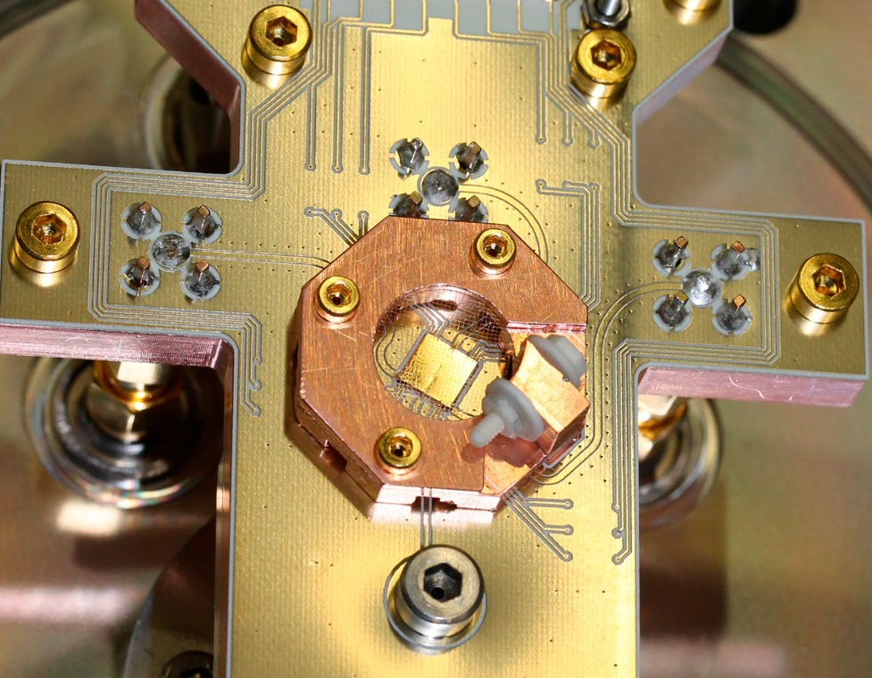

provides the secretariat. Based on this preliminary work, a Joint Technical Committee JTC 22 requested by DIN was recently approved by CEN-CENELEC, the innaugural meeting of which was held in Berlin in March 2023.

PTB is also working with various partners to develop further [**training courses for industry**](https://www.quantum-training-alliance.de/home). The goal here is to support the coherent and well-coordinated devel-opment of offers in Germany, with the intention of avoiding duplication and providing effective and easy access for interested parties from industry, moving beyond thematic or regional interests.

### Wissenschaftsgemeinschaft Gottfried Wilhelm Leibniz e. V. [Leibniz Association]

In the value chain, Leibniz Association institutions cover the gamut from fundamental research on quan-tum phenomena and materials to material and device development, as well as systemic heterointegration and prototype solutions. They research a wide variety of material systems and technology approaches to

develop innovative solutions. Completely new possi-bilities can arise, for example, from the lived merging of research in microelectronics and materials sciences. With this, research into new oxide, metallic, organic and hybrid functional and nanomaterials and struc-tures is undertaken, which could have great potential for future micro- and nanotechnologies, thereby addressing aspects of integrated smart systems, nano-electronics and quantum computing.

Within the Leibniz Association the following in-stitutes conduct research in the field of quantum technologies: the Ferdinand Braun Institute – the Leibniz Institute for Highest Frequency Technology (FBH), the Leibniz Institute for Solid State and Mate-rials Research (IFW), the Leibniz Institute for Innova-tive Microelectronics (IHP), the Leibniz Institute for Crystal Growth (IKZ), the Leibniz Institute for Surface Modification (IOM), the Leibniz Institute for Photonic Technologies (IPHT), the Paul Drude Institute for Solid State Electronics (PDI) and the Weierstrass Institute for Applied Analysis and Stochastics (WIAS).

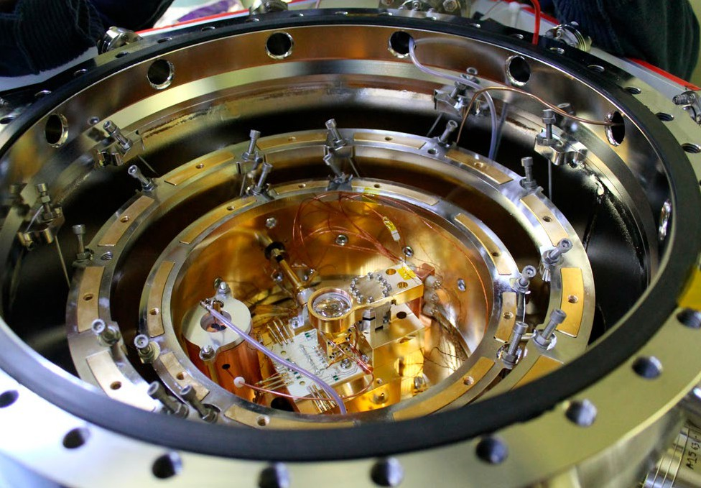

In addition, the disciplinary breadth of the Leibniz Association also covers economic and social science aspects of the new technologies and opens up new areas of application in the natural, environmental and life sciences.

The interdisciplinary Leibniz Institutes conduct research in the three main areas of quantum commu-nication, quantum metrology and sensor technology, and quantum computing, as well as on ‘enabling’ technologies, in particular photonics, laser, micro-wave, signal and cryogenics, control electronics, integrated systems and new software algorithms.

They develop materials for quantum technologies and characterise the corresponding optical, electrical and structural properties, conduct research on the

effects of light-matter interaction and the phenomena of quantum and nanophotonics, and therefore make

a fundamental contribution to knowledge-oriented research questions in quantum physics. The Leibniz Institutes also supply European research institutes with critical material systems such as isotopically pure semiconductors, therefore making an impor-tant contribution to increasing the resilience of the European Research Area. With the help of innovative

processes and process technologies, as well as through modelling and simulation, it is possible to design

and develop new components: electronic or opto-electronic semiconductor components, multi-qubit circuits, quantum sensors and detectors, qubit control, drive and readout circuits. Individual Leibniz in-stitutes master the systemic and hybrid integration

of these components and enable proof-of-concept demonstrators, complex systems and industrial-grade prototypes up to small-scale production. With regard to the tap-proof transmission of encrypted informa-tion, the institutes are researching photonic modules and their microintegration in the field of quantum communication. In respect of quantum metrology and sensor technology for navigation, the synchro-nisation of networks, medical diagnostics and highly sensitive imaging techniques, research is undertaken to develop atomic quantum sensors, quantum sensors based on optically pumped magnetometers and defect centres, as well as sensory surfaces.

In the field of quantum computing, which is impor-tant for potential tasks in critical application fields such as chemistry, meteorology, finance and for mate-rial or drug development, the institutes are research-ing both superconducting and spin-based quantum bit systems as well as components and modules for optical photonic quantum computing and for quan-tum computing based on isotopically pure semicon-ductor systems and ions.

The Leibniz Institutes are involved on a national level in relevant projects, such as the Excellence Hub

*ct.qmat – Complexity and Topology in Quantum Matter*, the Research Factory Microelectronics Germany, *QSolid – Quantum Computers in the Solid State, MU-NIQC-SC – Munich Quantum Valley Quantum Comput-er Demonstrators – Superconducting Qubits, or QYRO – Nuclear Spin-based quantum gyroscopes for new space applications*, as well as an international level, for example, at *BECCAL – Bose-Einstein Condensate and Cold Atom Lab* on the International Space Station.

Under the umbrella of the Leibniz Strategic Forum *Technological Sovereignty*, the Leibniz institutes have begun to pool their expertise on ‘quantum technolo-gies’, among other things, by coming together in a hub since 2021, thereby deepening cooperation.

### Zentrum für Digitalisierungs- und Technolo-gieforschung der Bundeswehr [Centre for Digitisation and Technology Research of the Bundeswehr] ([dtec.bw](http://dtec.bw/))

The [dtec.bw](http://dtec.bw/) is a scientific centre supported by both universities of the German Armed Forces and, as a measure, is part of the Federal Government’s 2020 *Corona-Folgen bekämpfen, Wohlstand sichern, Zukun-ftsfähigkeit stärken [Fighting the Consequences of Covid, Securing Prosperity, Strengthening Future Capabili-*

*ty]* fiscal stimulus package. It is subject to academic self-administration. The funds provided to [dtec.bw](http://dtec.bw/) by the BMVg division will be used at both Bundeswehr universities to finance research projects and projects for knowledge and technology transfer. One of the ongoing projects is *MuQuaNet: quantum internet in the greater Munich area*.

The aim of the project is to develop, build and operate a quantum-safe communication network for research and evaluation with the University of the Bundeswehr Munich at the heart of it, making it available to other research institutions, authorities and services of the Bundeswehr. Constructed from different components, it was designed to prepare for the seamless integration into today’s network communications, demonstrate the wide range of applications and serve as a blueprint for building custom, highly secure communications networks.

7. Glossary

### Defects in diamond or NV centres

Impurities of a diamond lattice due to individual foreign atoms, such as nitrogen (‘nitrogen vacancy’). This forms an excited spectrum that can be used, even at room temperature, as a single photon source, as

the computing unit of a quantum computer or, due to its sensitivity to magnetic fields, as a highly sensitive sensor.

### R&D: Research and development

Refers primarily to pre-competitive work in a com-pany or research institution that carries a significant technical risk. This is in contrast to competitive or experimental development, as well as product devel-opment.

### Full stack

Refers to the sum of all components of a platform or an overall technical system that build on each other. The origins of the term lie in software development. In terms of quantum computing, however, the hard-ware components are also included.

### Galileo

A system of navigation satellites operated by the Eu-ropean Union, which are comparable to the American GPS (Global Positioning System).

**SMEs: Small and medium-sized enterprises** According to the definition by the EU, these are com-panies with fewer than 250 employees and an annual turnover of no more than EUR 50 million or a balance sheet total of no more than EUR 43 million.

### NISQ: Noisy intermediate scale quantum com-puter

Interim objective of achieving ‘medium-sized’ quan-tum computers with 50 to a couple of 100 qubits.

These are intended to demonstrate the potential of quantum computers beyond simulations, but will still be severely limited in terms of their computing power due to a lack of control over all qubits.

### Optical clock

Also known as an atomic clock. The frequencies of atomic transitions, usually caesium or rubidium, can be used to calculate a highly accurate time signal. The method has been used for decades to measure world time. However, further technological advances with regard to methodology may also mean it is suitable for future use in telecommunications or for measuring the absolute elevation in terrain (relativistic geodesy).

### PQC: Post-quantum cryptography

Describes the need to further develop or replace current encryption methods if they can no longer be deemed secure given the new computing possibilities of quantum computers.

### Quantum gyroscope

Refers to a measuring device that uses quantum effects to measure rotational movements and their rates of rotation. (Quantum) gyroscopes are used in particular for navigation applications.

### QKD: Quantum key distribution

Encryption technology for data communication. In contrast to methods that are currently used, QKD uses the quantum mechanical property of entanglement of states during data transmission and is therefore intrinsically interception-proof, meaning that any eavesdropping or tapping could always be detected, resulting in a breakdown of communications.

### Qubits: Quantum bits

Smallest logical computing unit of a quantum computer in analogy to the bits of traditional com-puters. In contrast to these, qubits can also assume arbitrary states between ‘0’ and ‘1’, which is one of the key features and potential advantages of a quantum computer.

### TRL: Technology readiness level

Describes the stage of maturity of technologies. The scale ranges from TRL 1 (description of the functional principle) to TRL 9 (qualified system with proof of successful use). TRL 5 describes a test set-up in an operational environment.

## Imprint

**Published by**

Bundesministerium für Bildung und Forschung/ Federal Ministry of

Education and Research (BMBF)

Quantum Technologies; Quantum Computing, 53170 Bonn, Germany

**April 2023 Edited by**

Die Bundesregierung / Federal Government

**Layout**

neues handeln AG

**Printed by**

BMBF

**Photo credits**

Titel: Fraunhofer ILT, Aachen/Volker Lannert

S. 3, 19, 34: Bayerische Akademie der Wissenschaften BAdW/ Kai Neunert

S. 4, 11, 25: TRUMPF Gruppe

S. 5, 28, 47, 50, 51: Physikalisch-Technische Bundesanstalt PTB

S. 6, 8, 16, 29: MCQST/Jan Greune

S. 9: MPQ/Thorsten Naeser

S. 14: MCQST

S. 18: AdobeStock/Vladimir Borovic

S. 21: AdobeStock/Gorodenkoff/aLListar/peopleimages.com

S. 22: AdobeStock/Have a nice day

S. 31, 32: MCQST/Christoph Hohmann

S. 35, 37, 45: Fraunhofer ILT, Aachen/Volker Lannert

S. 39: Fraunhofer IAF

S. 40: AdobeStock/visoot (KI-generiert)

S. 42: AdobeStock/Gorodenkoff

This specialised publication of the Federal Ministry of Educa-tion and Research is available free of charge. It is not for sale and may not be used by political parties or groups for electoral campaigning.

[**bmbf.de**](http://bmbf.de/)

 [**@BMBF_Bund**](https://www.x.com/BMBF_Bund)  **@**[**bmbf.de**](http://bmbf.de/)

 [**@bmbf.bund**](https://www.instagram.com/bmbf.bund)